What are the Anaconda and miniconda. And what is difference between them?

Conda is a powerful package manager and environment manager that you use with command line commands at the Anaconda Prompt for Windows, or in a terminal window for macOS or Linux.

Like pip – package manager in Python, these conda open source software provides same operations but with installer. Conda also creates a virtual environment

Both Anaconda and Miniconda uses [Conda](https://conda.io/docs/index.html) as the package manager. The difference among Anaconda and Miniconda is that Miniconda only comes the package management system. Where Anaconda comes with package management system and with bundle of pre-installed packages.

Jupyter Lab and Jupyter Notebook are interactive computing environments that provide a user-friendly interface for working with code, data, and visualizations.

Jupyter Lab and Jupyter Notebook, when combined with Miniconda and Conda packages, create a powerful environment for interactive computing, data analysis, and collaboration. They streamline the process of managing dependencies, experimenting with code, and documenting your work, making them valuable tools for data scientists, researchers, and developers alike

**Setting path by command line:**

Temporary setting > set PATH=C:\Your\Path\Here;%PATH%

Permanent setting> setx PATH “%PATH%; C:\Your\Path\Here”

**Download the conda and add to the path to install the Jupyter lab**

conda create --name myenv python=3.8

activate myenv

conda install -c conda-forge jupyterlab

jupyter lab

**conda env list**

Jupyter Lab interface, click on the "+" icon in the left sidebar and choose "Notebook" under "Python 3" to create a new Python notebook.

Virtual environments helps to manage and centigrade the all project dependencies at one place

# **Artificial Intelligence**

ANI and AGI

AI refers to development of computer system that can perform task that typically require human intelligence. These tasks include things like visual perception, speech recognition, decision-making, and language translation.

Narrow AI and General AI:

ANI or Narrow AI refers to artificial intelligence systems that are designed and trained for a specific task or a narrow set of tasks. These systems excel at performing a particular task but lack the broad spectrum of cognitive abilities that a human possesses.

Examples of ANI include voice assistants like Siri or Alexa, image recognition software, and recommendation algorithms used by streaming services.

AGI or General AI refers to artificial intelligence systems that have the ability to understand, learn, and apply knowledge across a wide range of tasks, similar to human intelligence.

AGI would have the capacity to perform any intellectual task that a human being can do, including reasoning, problem-solving, and understanding diverse domains of knowledge. Achieving AGI is considered a more complex and long-term goal in the field of AI research.

AI refers to development of computer system that can perform task that typically require human intelligence, **ANI is specialized for specific tasks, while AGI is a more generalized form of artificial intelligence that can handle a variety of tasks, approaching the level of human intelligence**

## **Machine Learning**

Sub set of AI

A field of study that gives computers the ability to learn without being explicitly programmed - software.

Training a computer system for specific task. Like **Supervisor learning** modules - speech recognize, language translation, online advertising, self-driving and image processing .

What is Data?  
 performance is directly propositional to the amount of data

**IT AI**

**Data Science: cross cutting set of AI**Science of extracting knowledge and insights of from data. – slide desk

**Deep Learning**

**Subset of machine learning**

Applies the logical thinking to take a decision after analysing the data called Artificial neural network

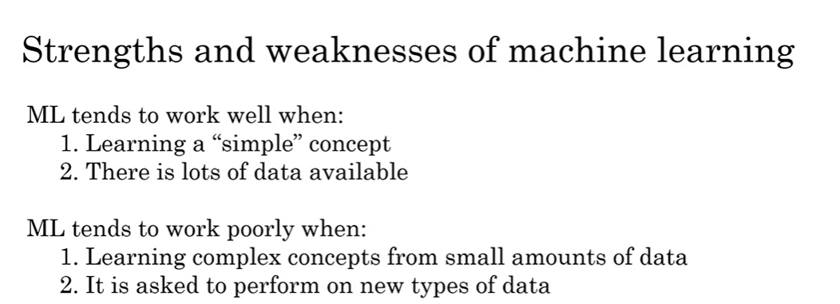

## **AI PROJECT**

Key steps of a machine learning project

1. Collect data
2. Train model
3. Deploy model

Workflow of Data science

1. Collect Data
2. Analyse Data
3. Suggest actions

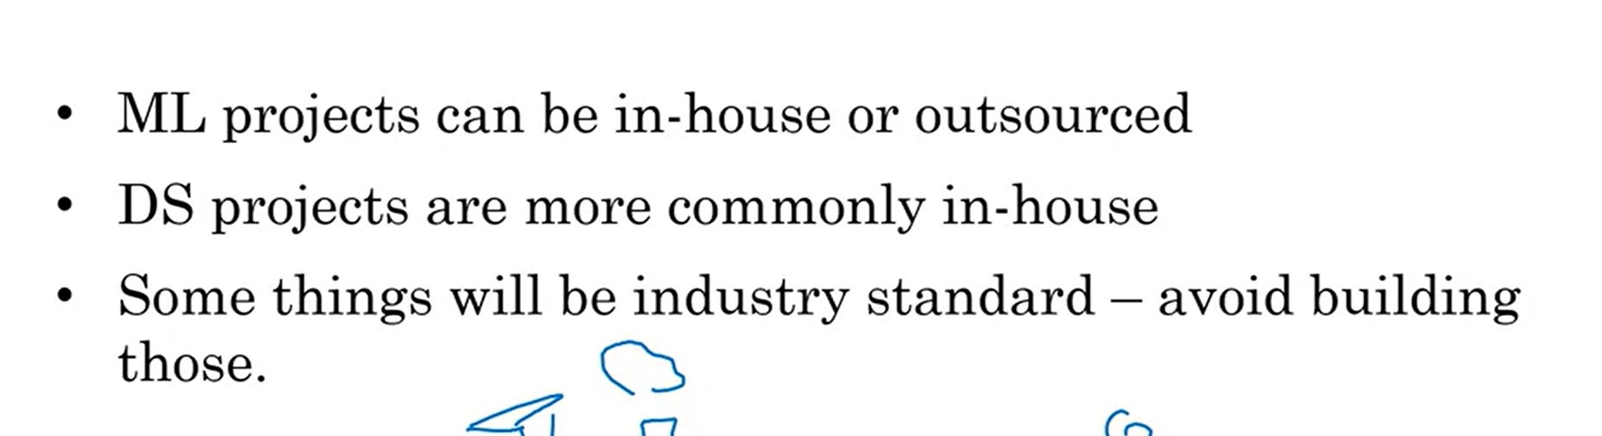

How to choose an AI project

> Looks at the task can automate using small or large dataset.

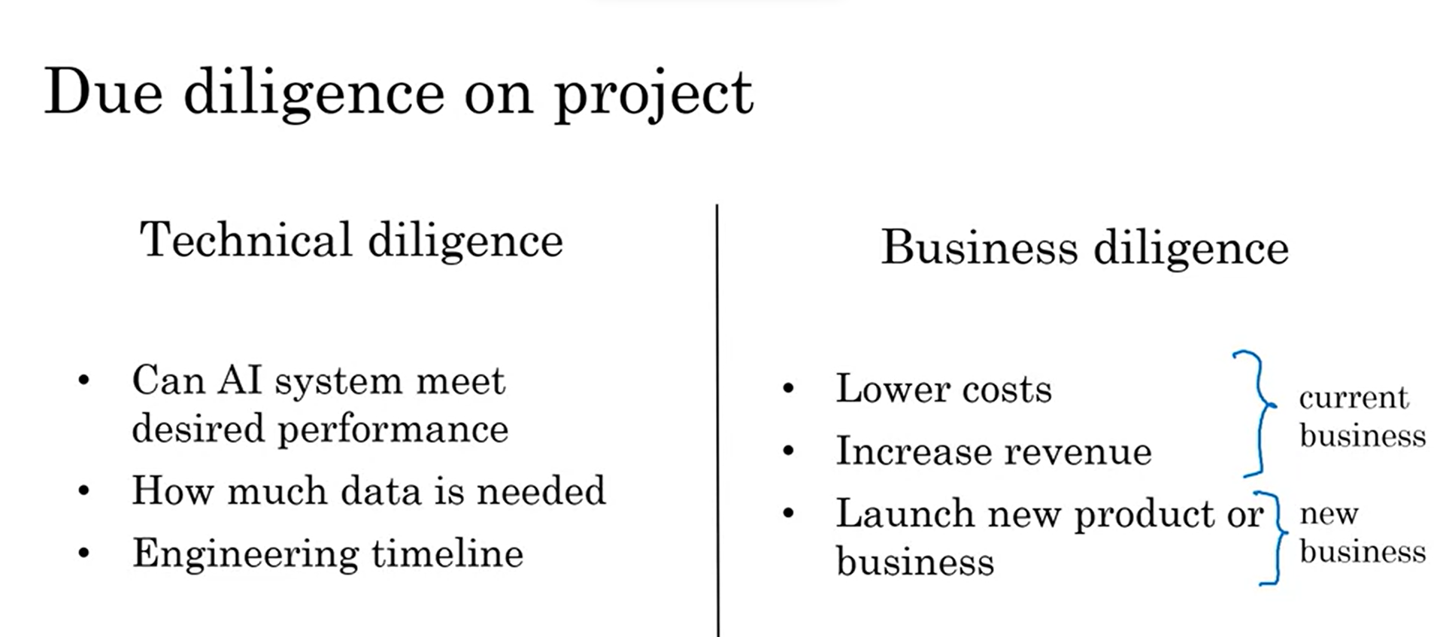

>Specify your acceptance criteria

>Data differentiation -Training set and Test set.

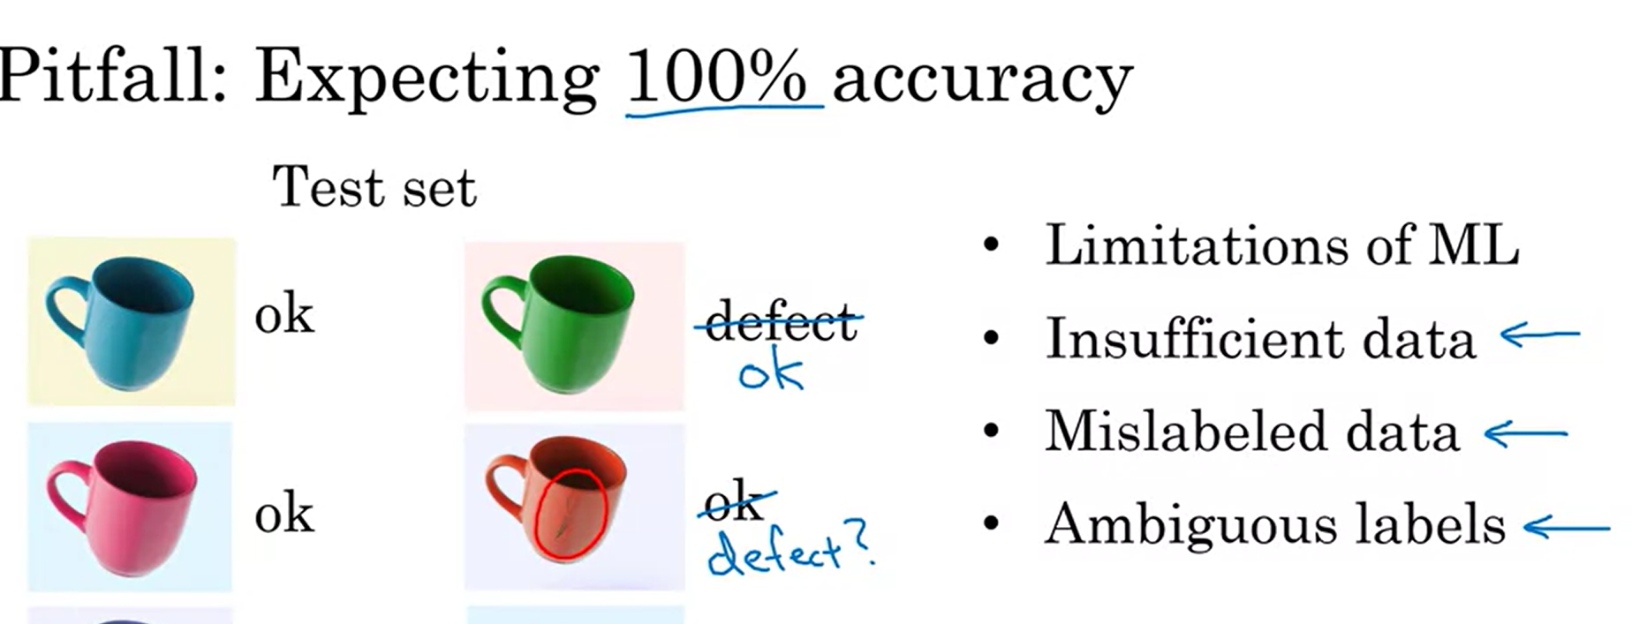

**Technical tools for AI Team**

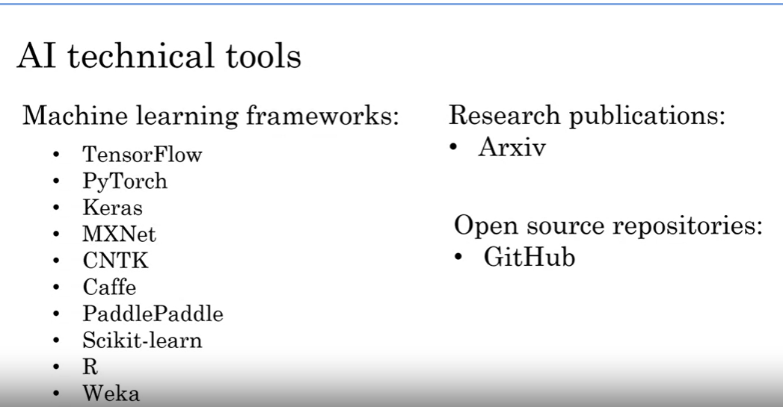

## Building an AI Project

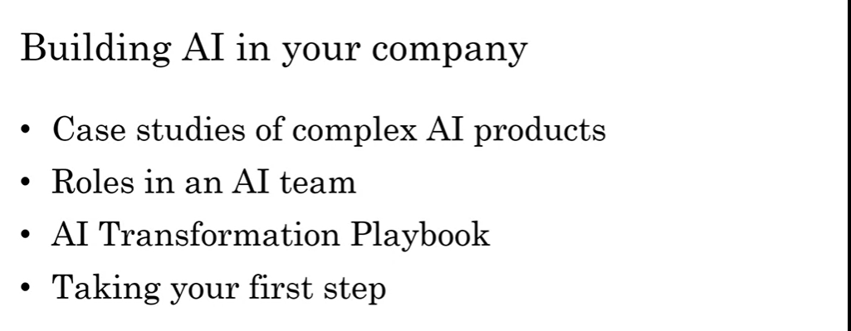

**Smart speaker case study**

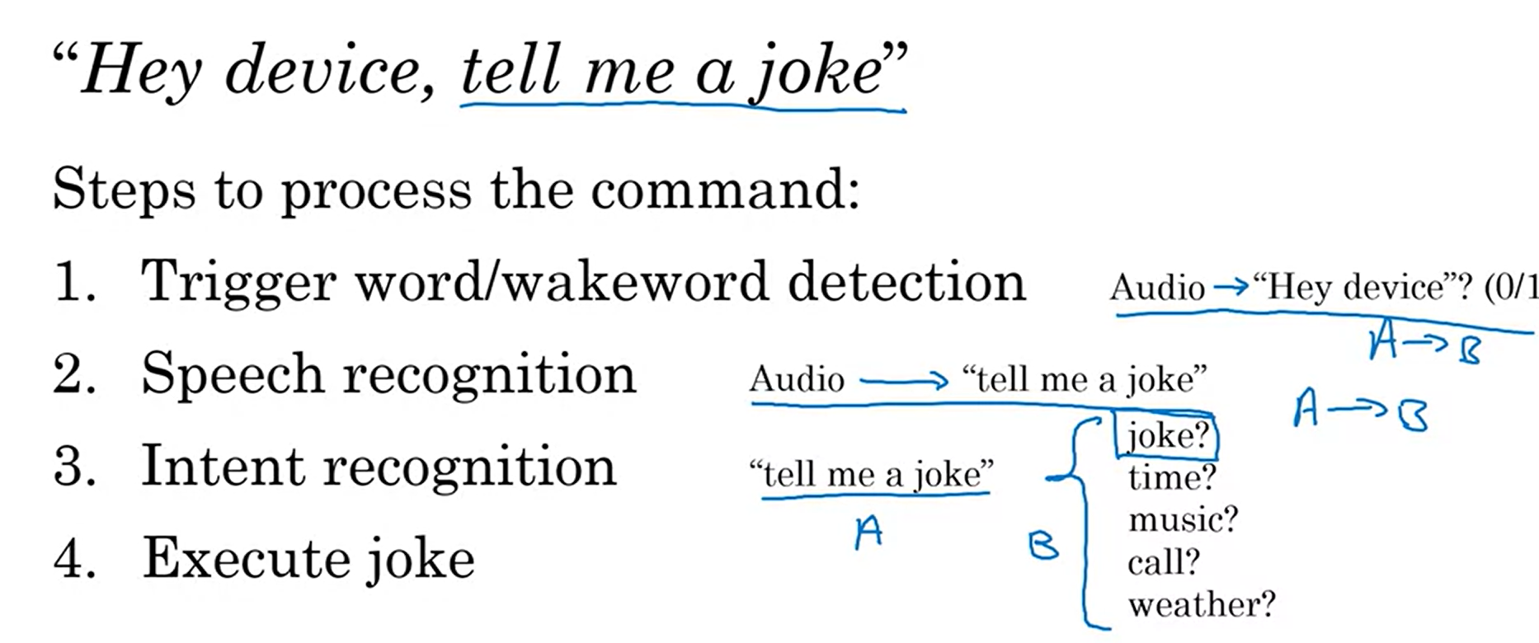

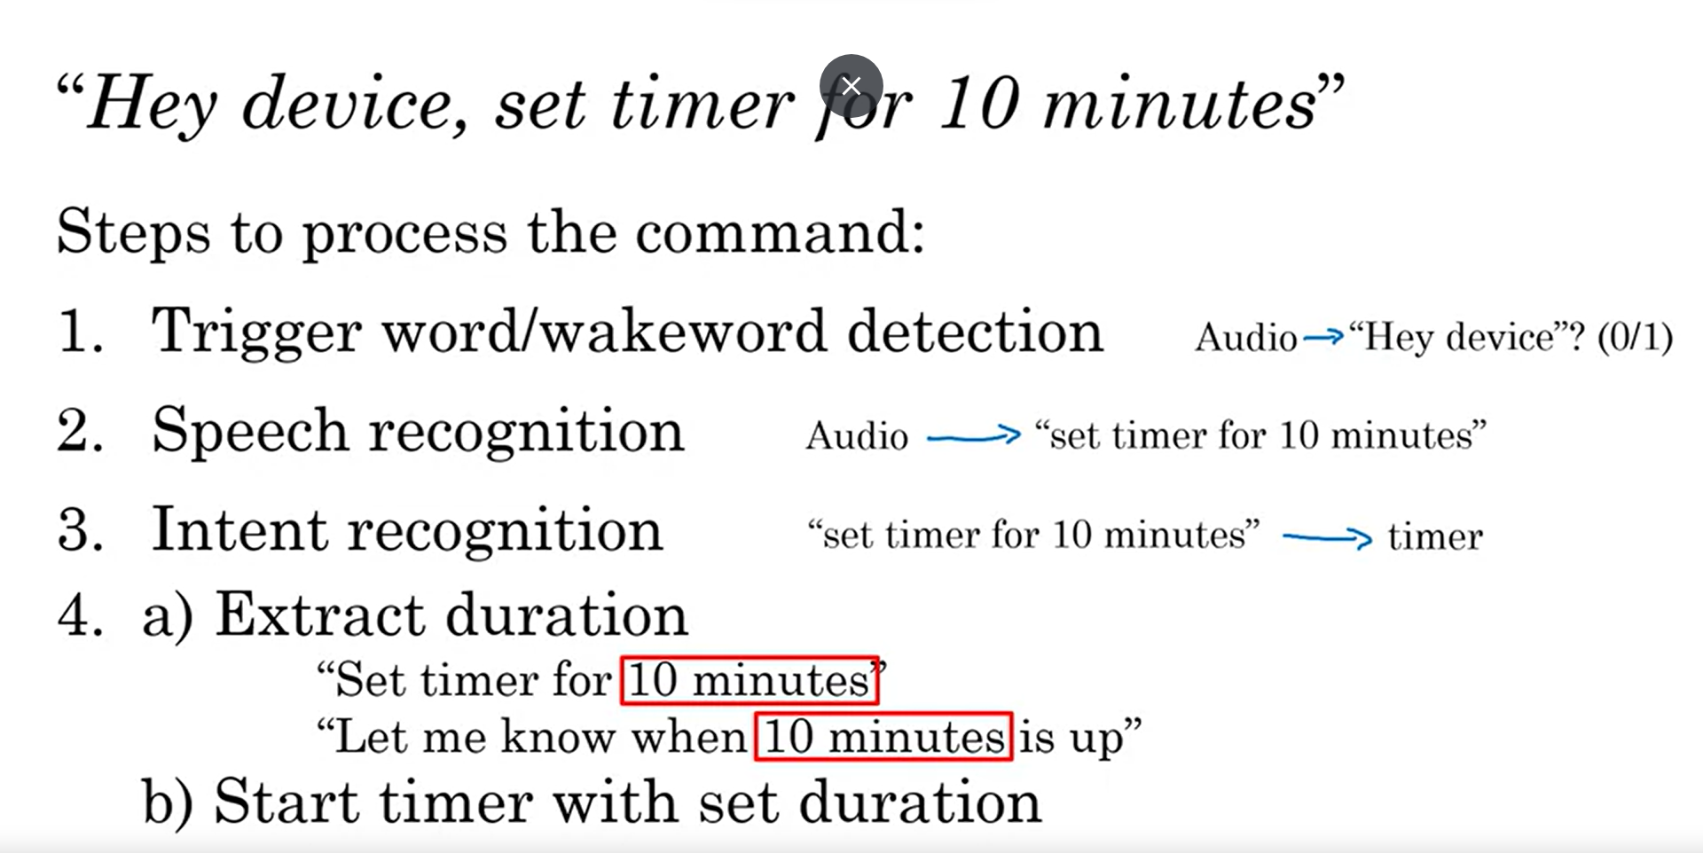

**Case Study for Self driving car**

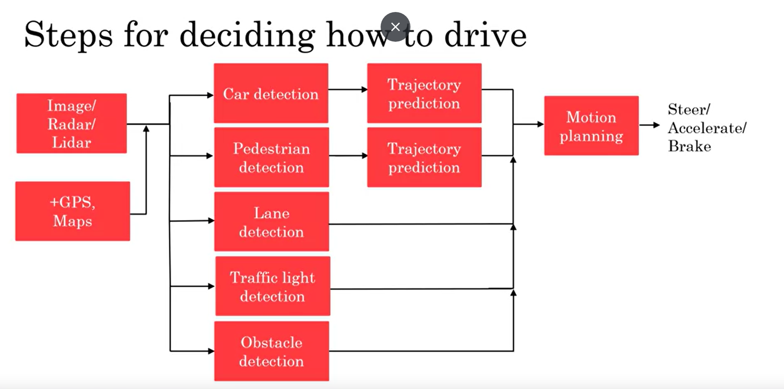

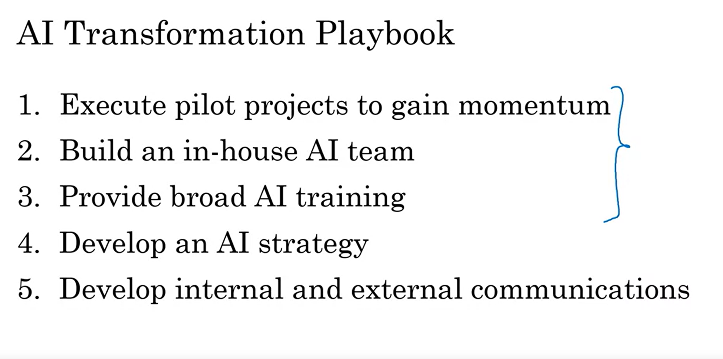

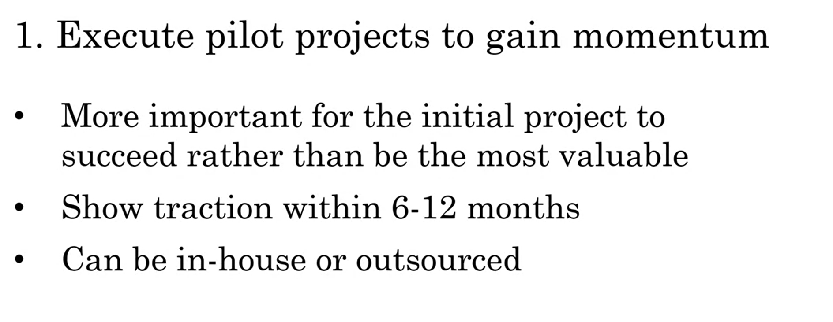

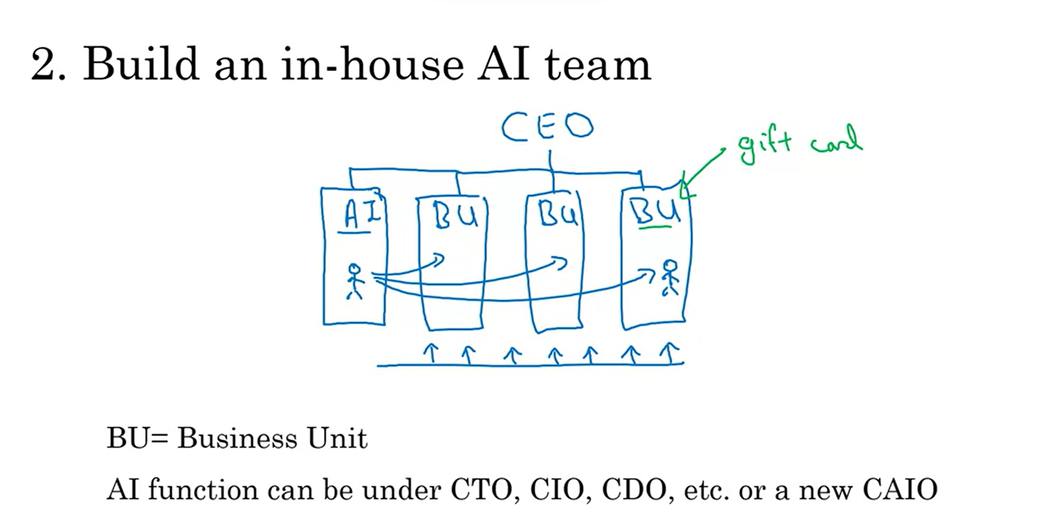

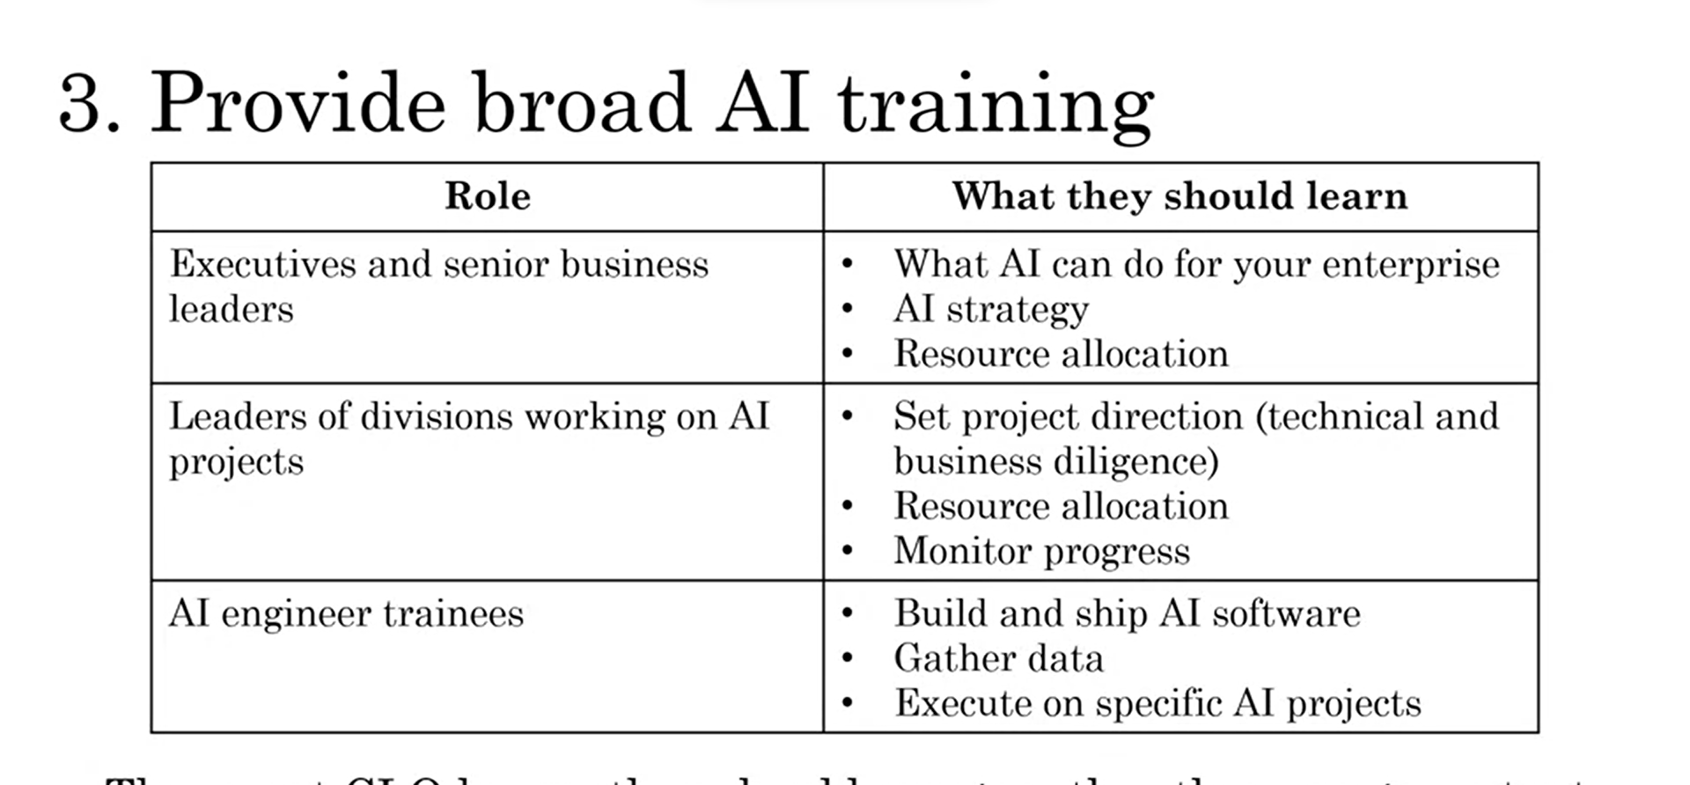

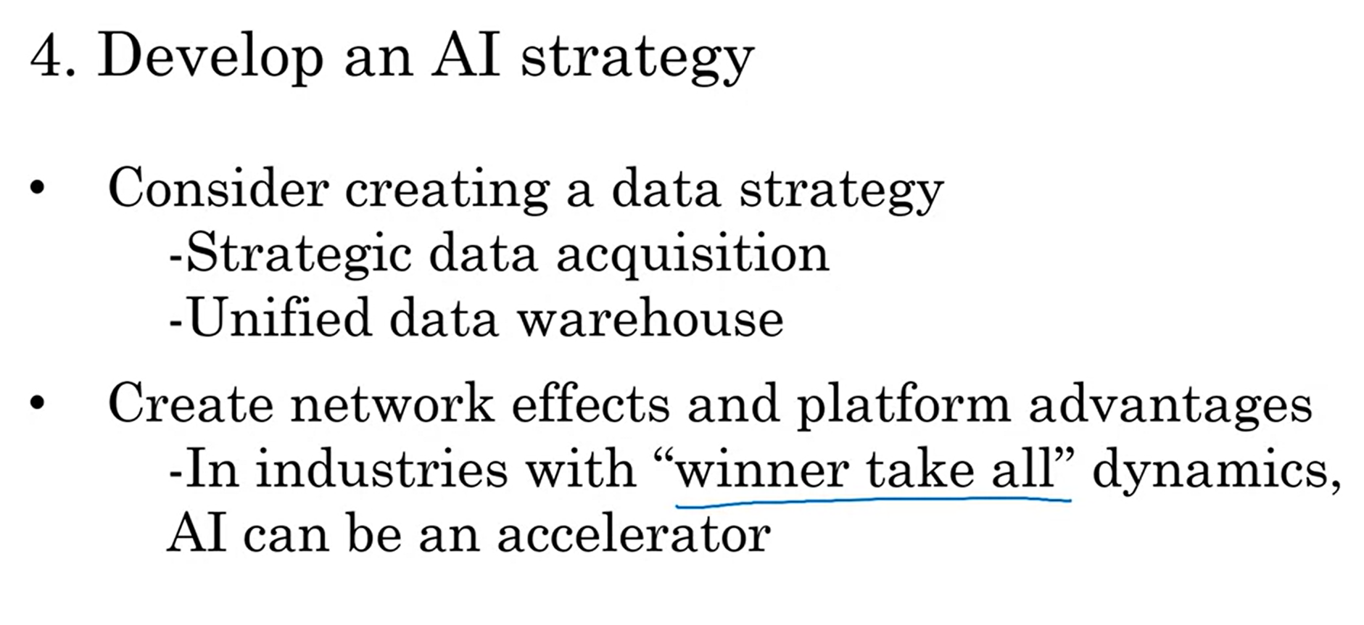

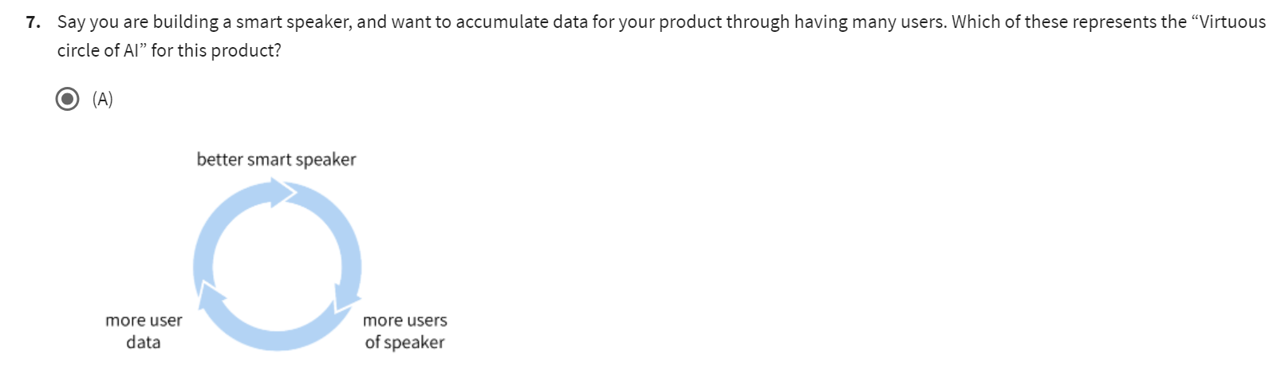

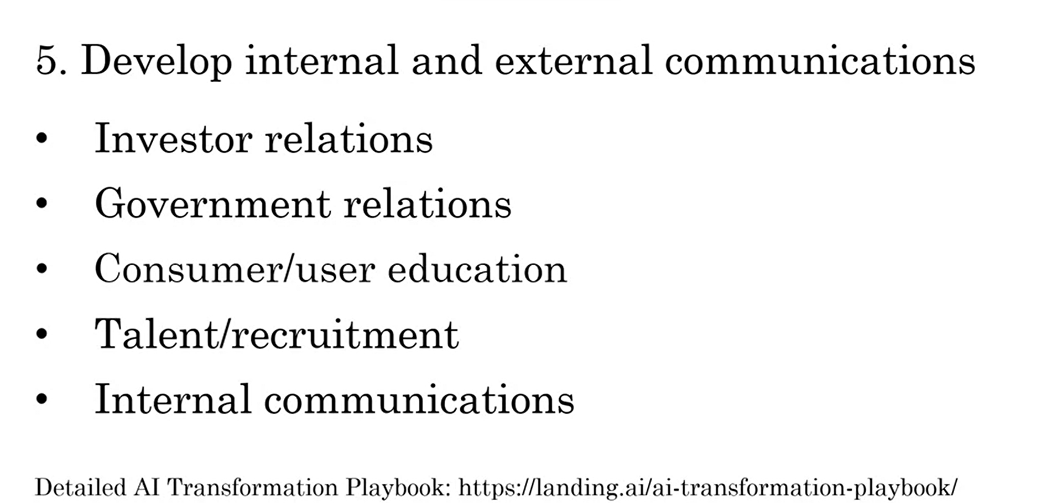

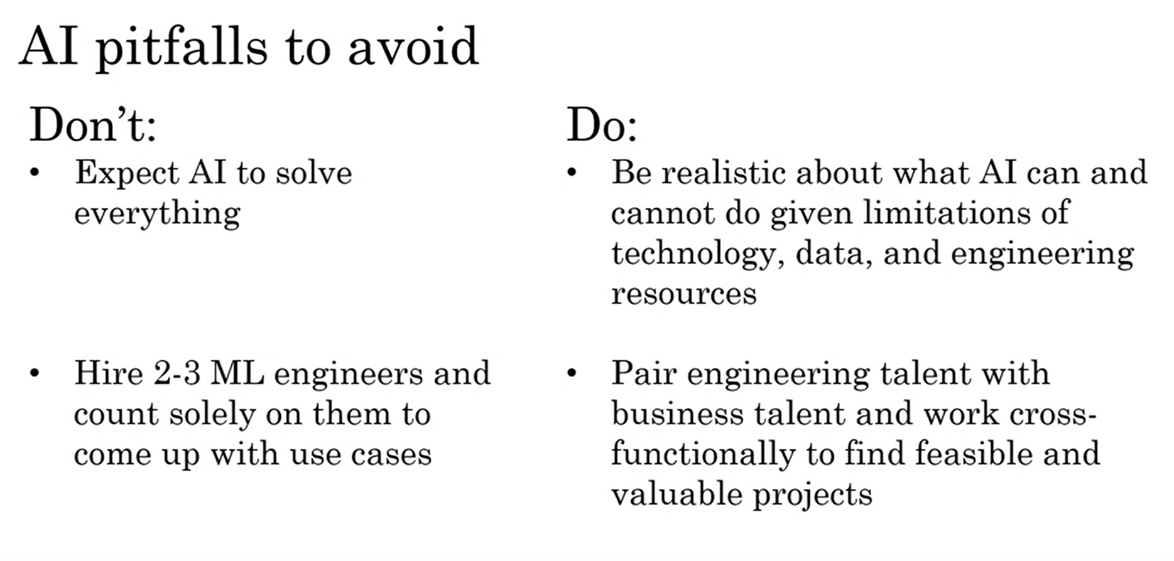

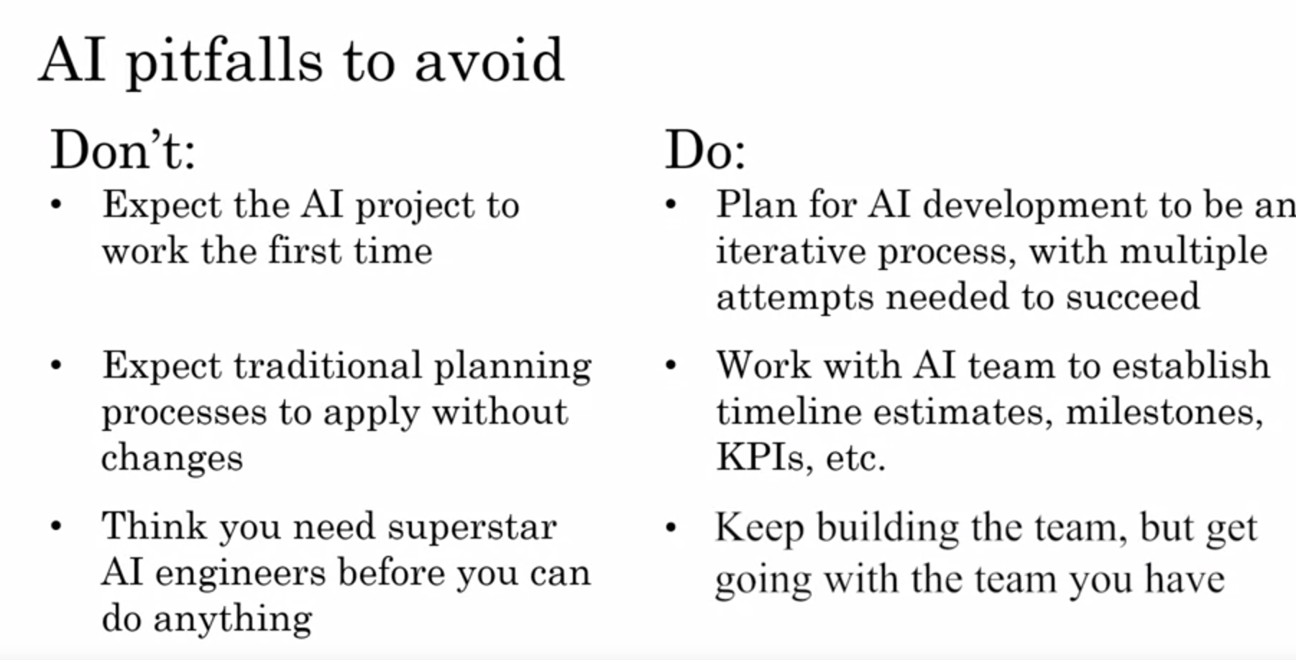

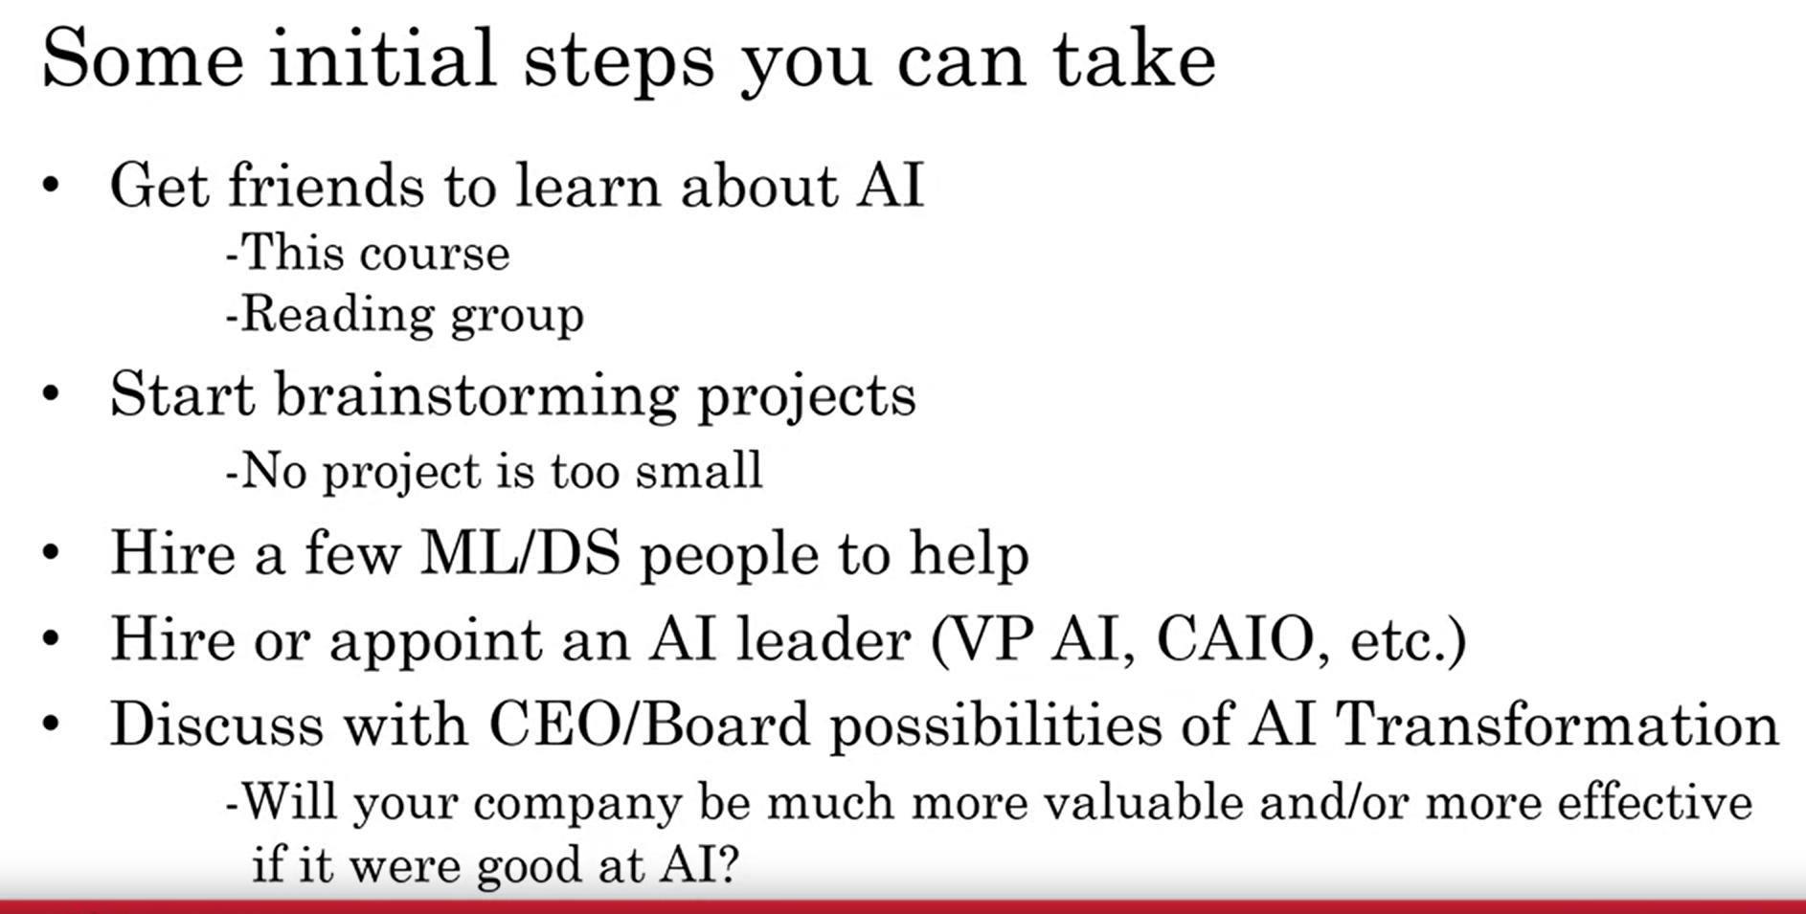

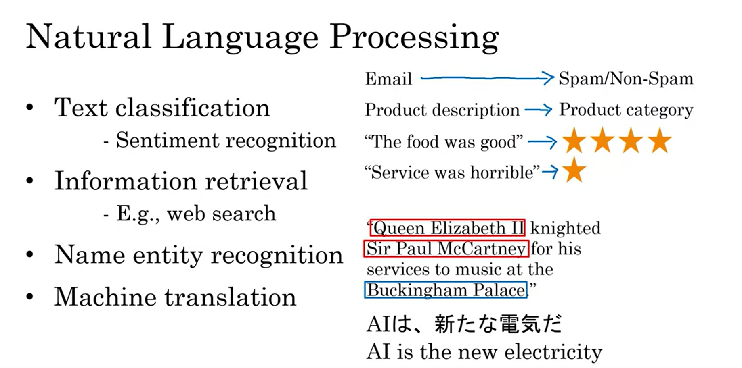

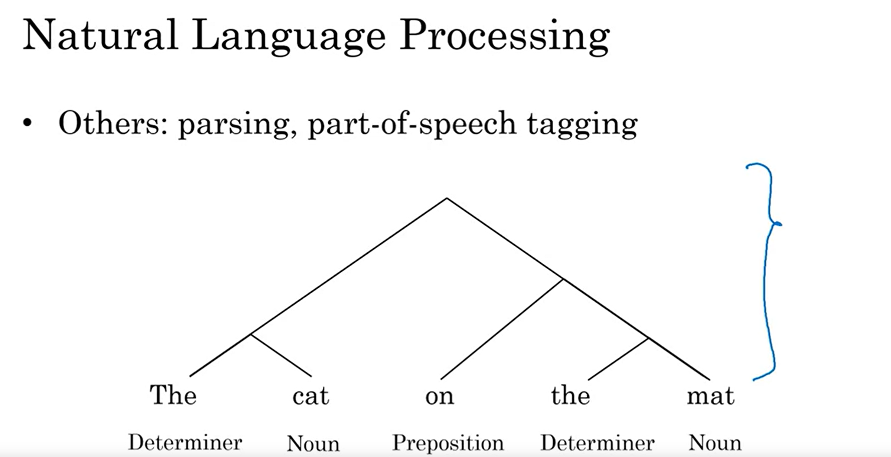

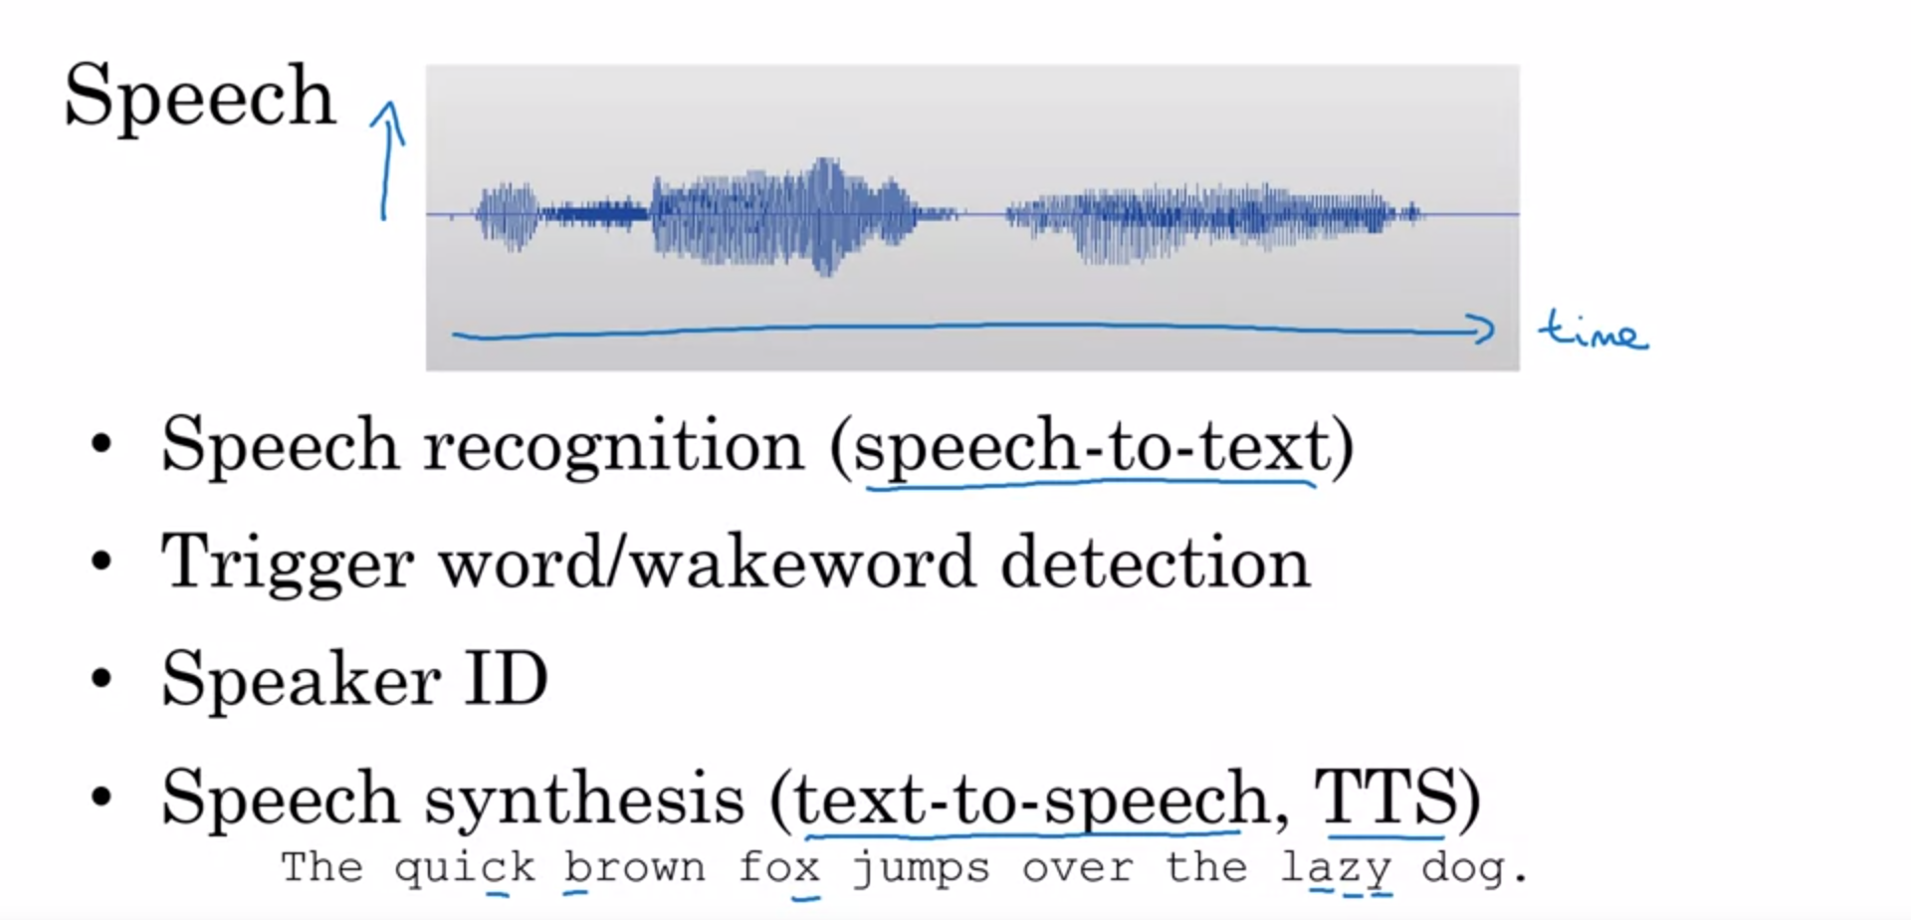

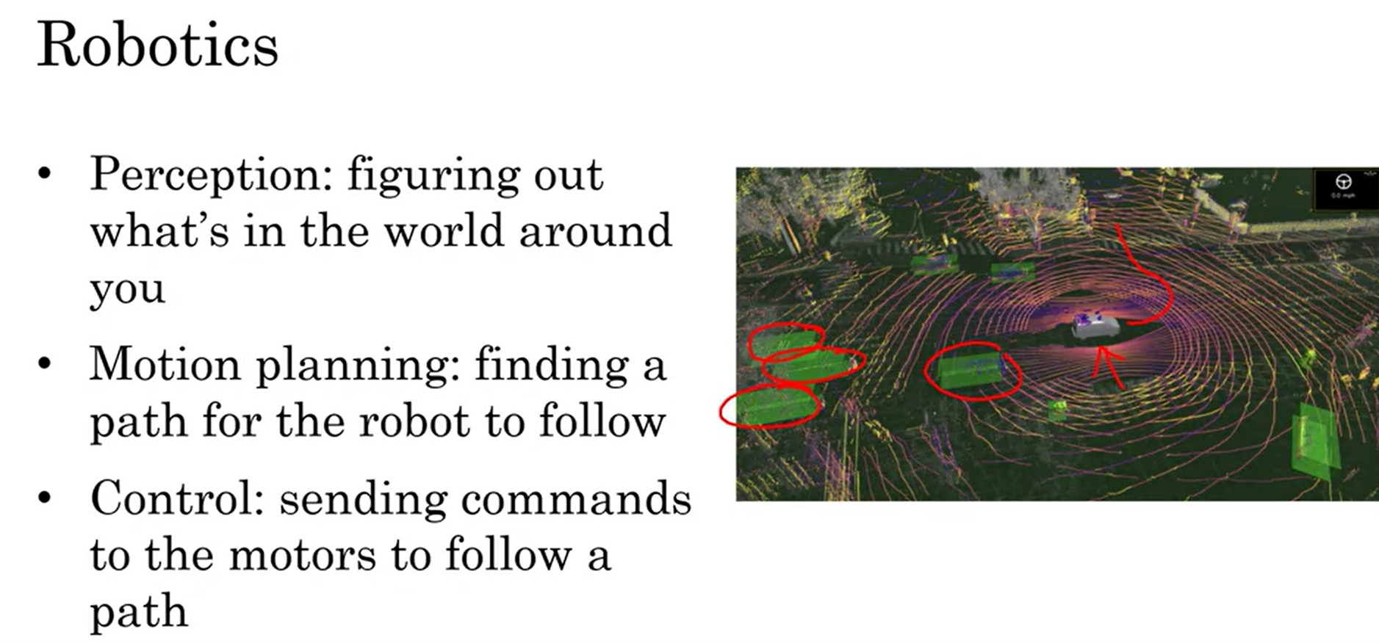

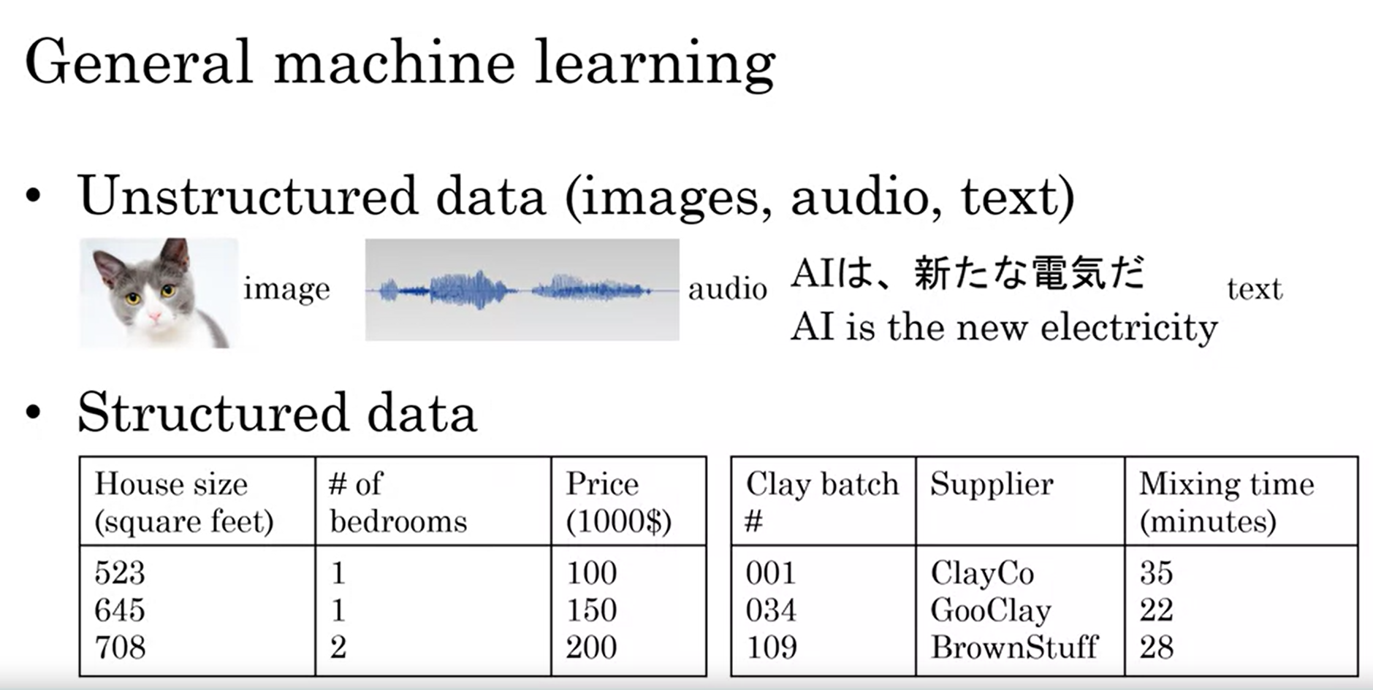

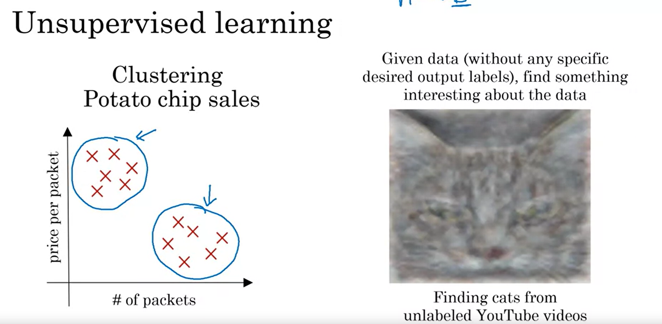

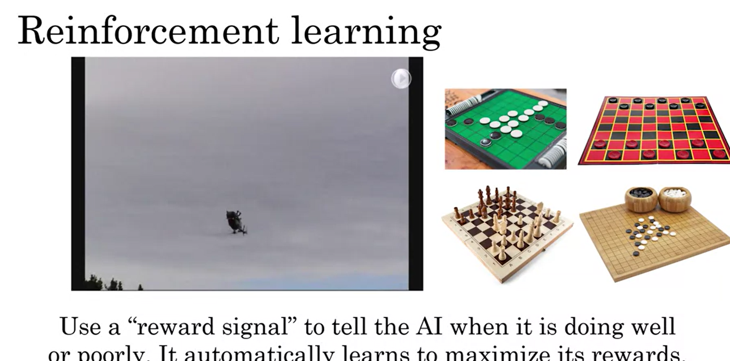

**Reinforcement learning - pricing, rewarding or encouraging.**

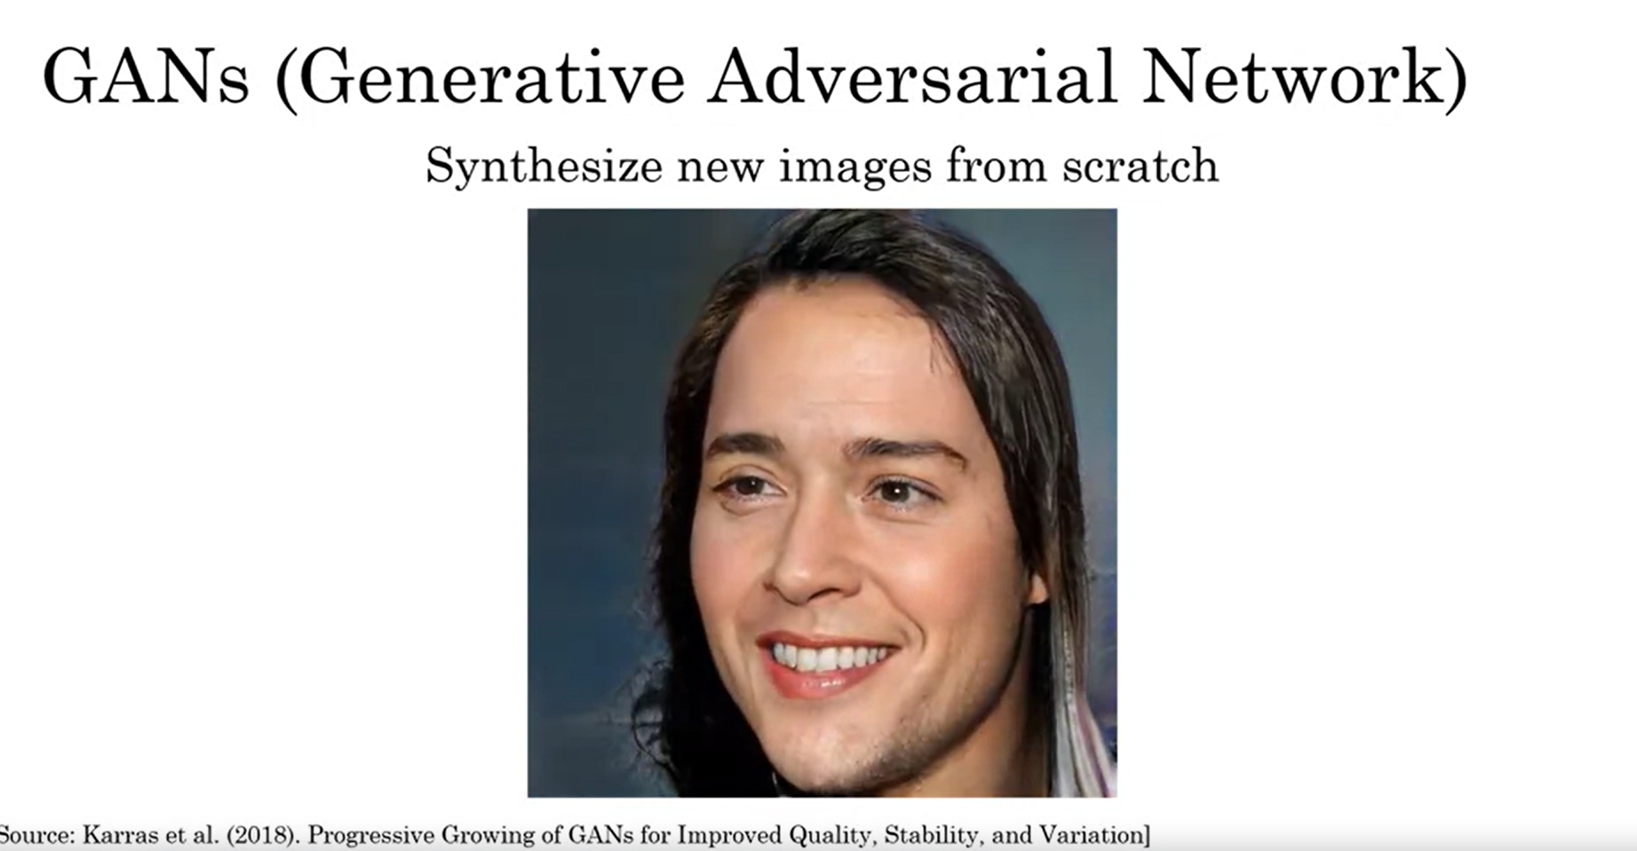

**Mostly used in Entertainment industry, creating new images from scratch**

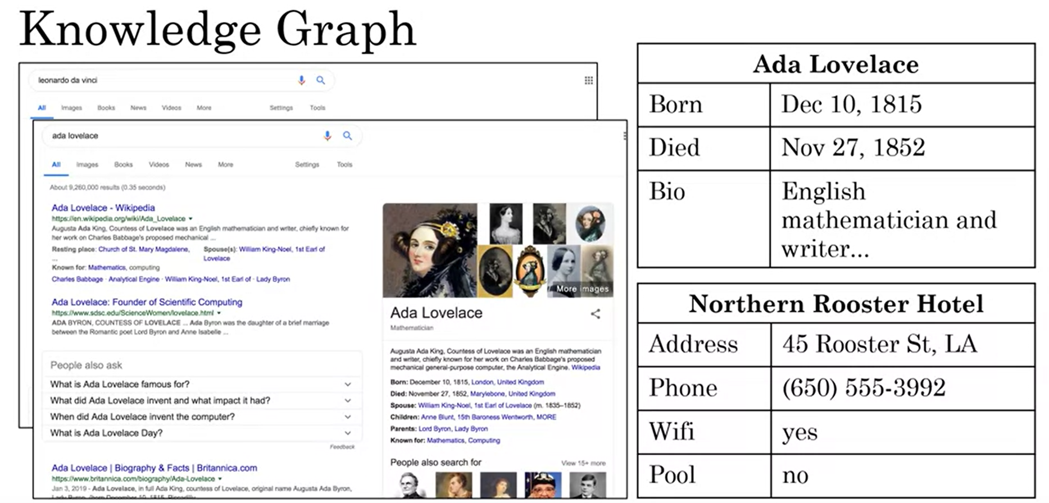

## **AI and Society – A realistic view of AI**

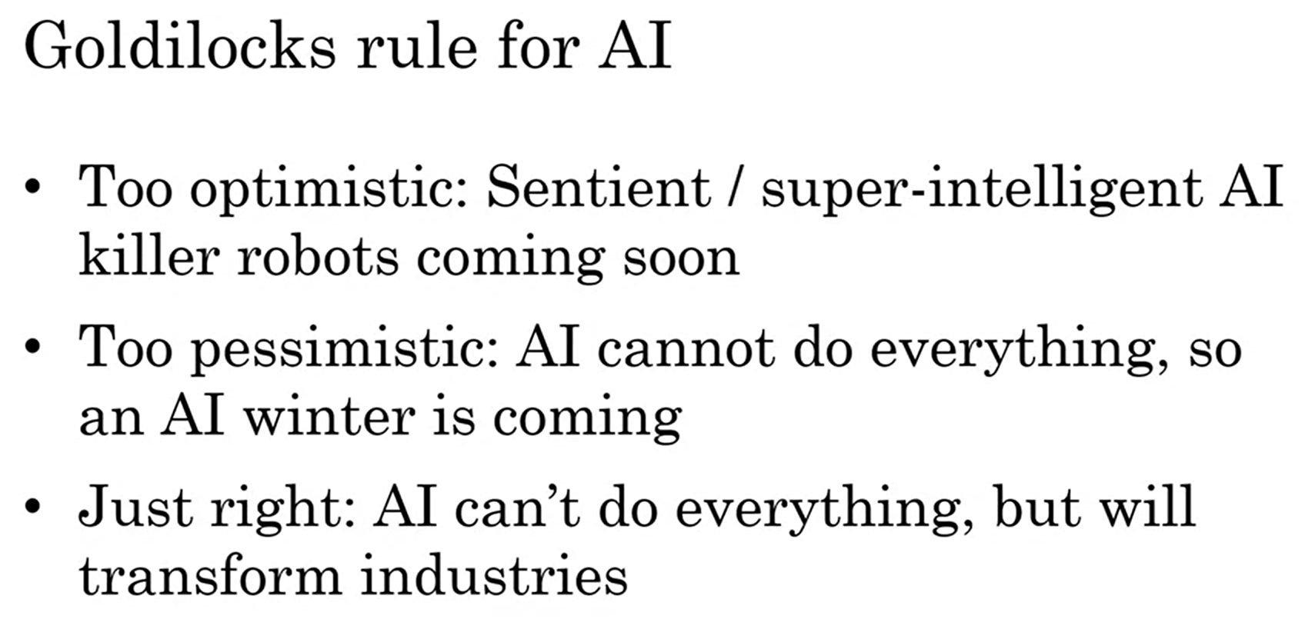



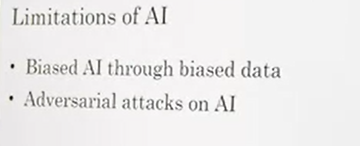

**Discrimination /Bias**

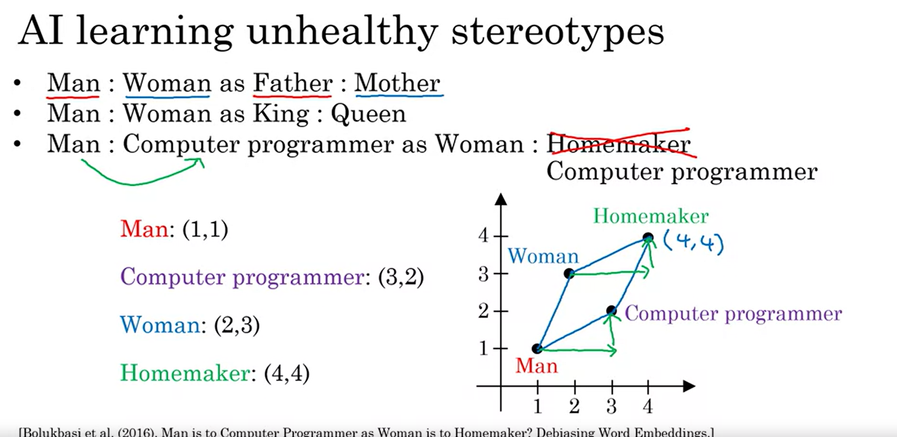

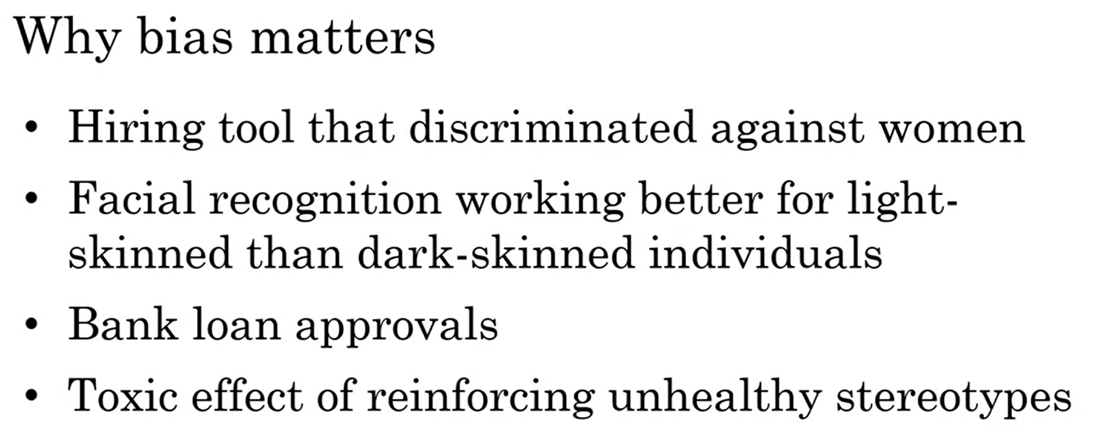

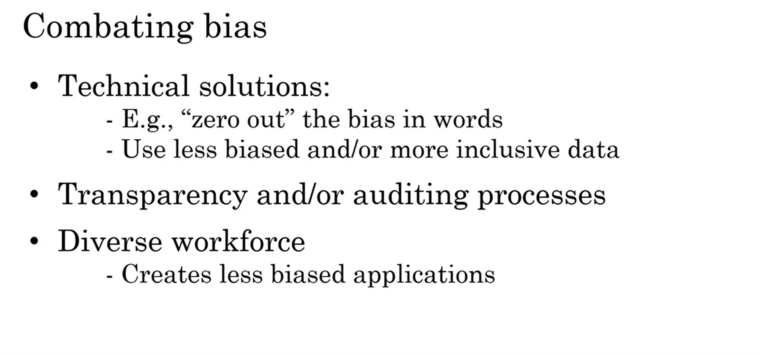

**Adversarial attacks on AI**

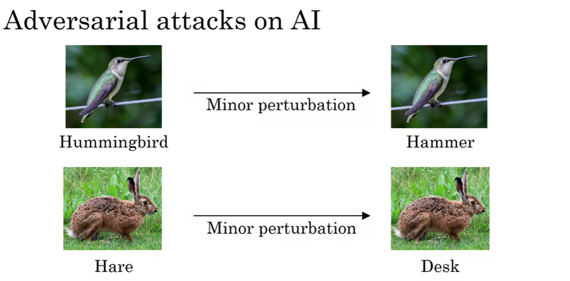

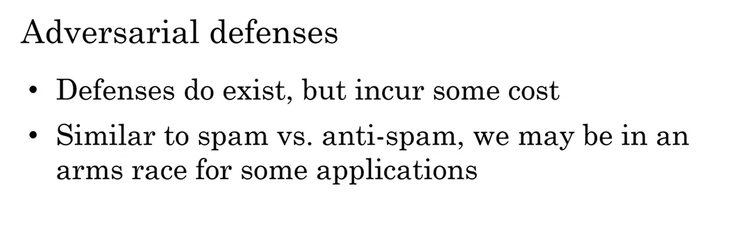

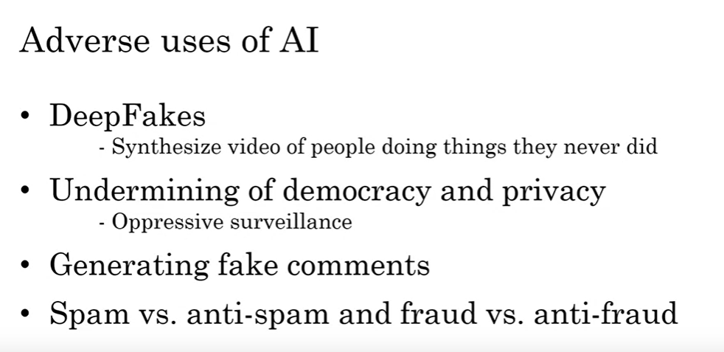

## AI and developing economics

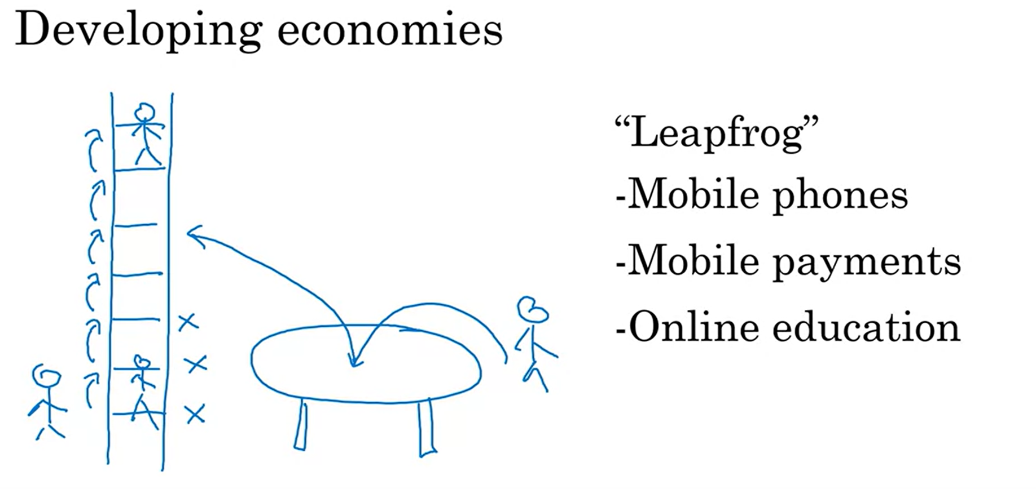

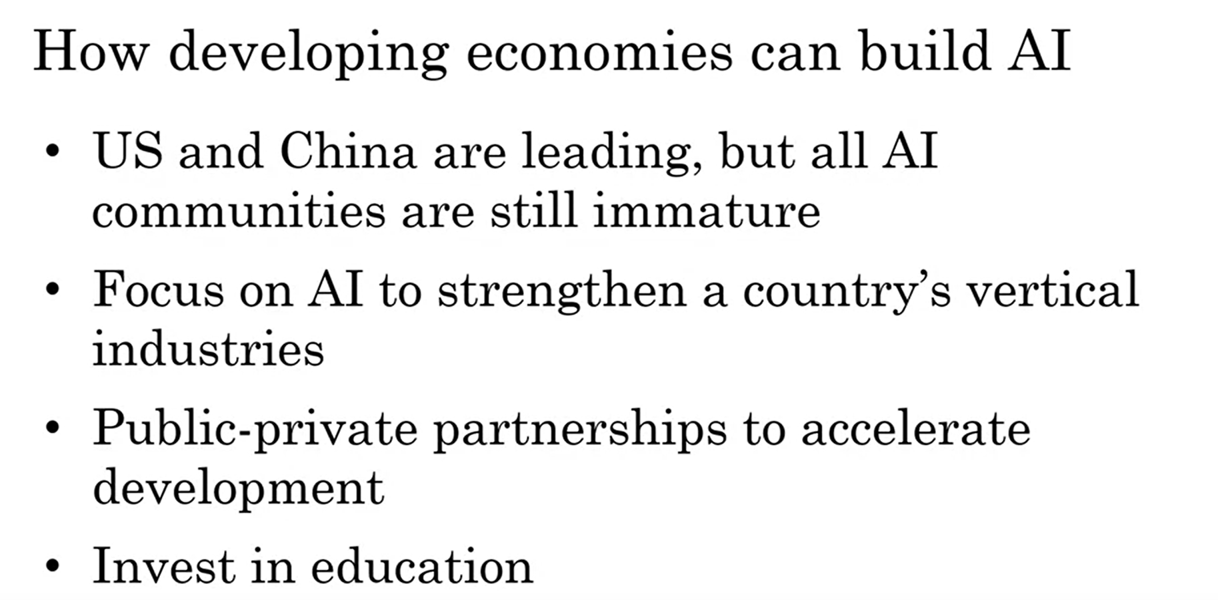

## **AI and Jobs**

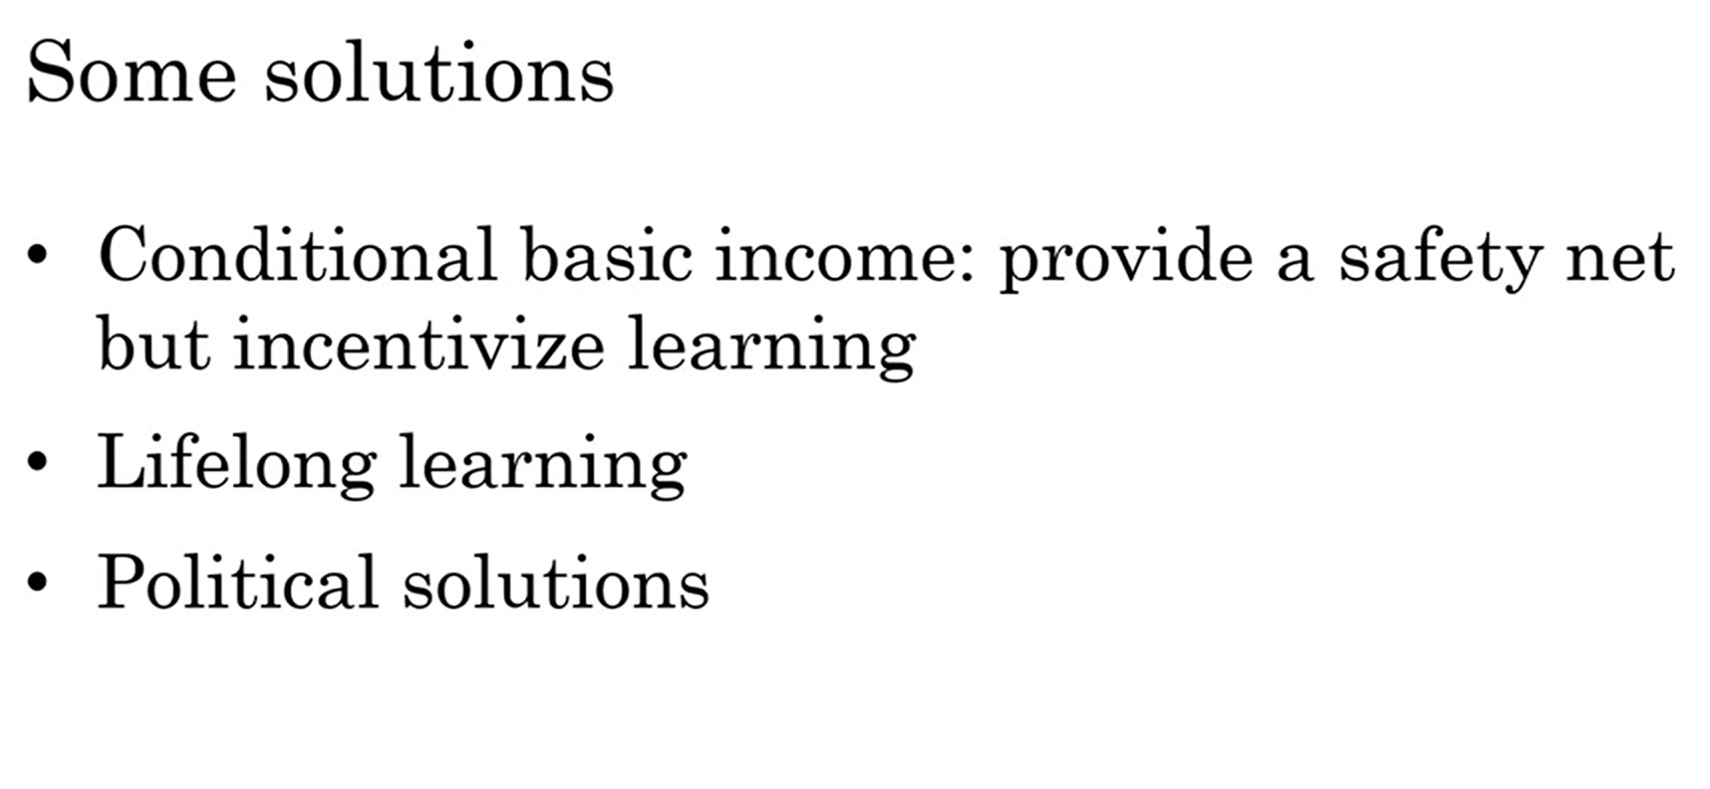

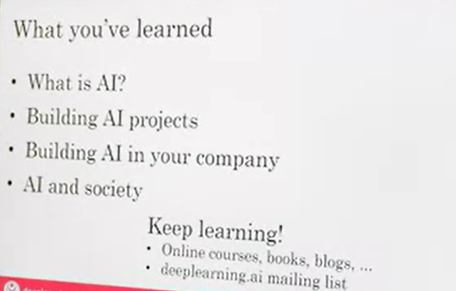

# **Generative AI**

Artificial Intelligence systems that can produce high quality content, specially text, images and audio.

A set of machine learning techniques that enable computers to generate new data based on existing input. Can be used to create anything from images and music to text and even 3D models

Banking:

Chatbots powered by Generative **AI can handle routine customer inquiries**, such as **balance inquiries and transaction history**, without the need for human intervention. By automating these processes, banks can improve response times and **reduce costs associated with staffing call centres**.

Retail:

Generative AI can generate **product photography and virtual fashion models** that showcase their items in a realistic and engaging way. This technology allows retailers to create high-quality visual content **without the need for expensive photoshoots or models**.

Telecom:

Generative **AI to create chatbots that can handle a wide range of customer inquiries and issues.** These chatbots can provide 24/7 support and are **capable of handling multiple conversations at once**, reducing wait times for customers.

Health care:

Generative AI algorithms can **analyze vast amounts of data from various sources, including medical records, genetic information, and clinical research studies to create a personalized treatment plan** that is tailored to each individual's unique needs.

Manufacturing

Generative AI to optimize the design of a specific component by analyzing **various design parameters such as size, weight, and material properties**. The algorithm can then generate multiple **design options that meet these criteria while also taking into account other factors such as cost and manufacturability**.

**Categories:**

Text to Image:

Here, AI transforms a text description into a visual representation. EG: Imagine providing a description like "a red ball on green grass," and the AI creates an image matching that description. Models: OpenAI - DALL-E 2 Google - Imagen, Muse

Text to 3D:

Here, AI translates a textual description into a detailed three- dimensional model. EG: Provide a description like "a modern skyscraper with glass windows," and the AI generates a 3D representation of that building. Models: Google - Dreamfusion, Nvidia - Magic3D

Image to Text:

Here, AI analyzes a visual representation and generates a textual description. EG: Provide an image of a red ball on green grass, and the AI creates a caption or tags describing the scene. Models: DeepMind - Flamingo, Microsoft – VisualGPT

Text to Video:

Here, AI converts a textual narrative into a dynamic video representation. EG: Provide a description like "a kitten playing with a ball of yarn," and the AI creates a video that showcases the playful interaction. Models: Google - Phenaki, Runaway

Text to Audio:

Here, AI converts a text description into an auditory experience. EG: Provide a text like "the soothing sound of waves crashing on the beach," and the AI generates an audio clip that captures the essence of the scene. Models: Google - AudioLM OpenAI – Whisper

Text to Text:

Here, AI processes a text input and generates new text based on that input. EG: Provide a description like "a red ball on green grass," and the AI creates a related sentence such as "A vibrant red ball sits atop lush green grass." Models: OpenAI - ChatGPT Notion – NotionAI

Text to code:

Here, AI translates a text description into functional code. EG: Provide a description like "create a program to calculate the area of a circle," and the AI generates code that performs the specified task. Models: OpenAI - Codex Google – Alphacode

Text to Science:

Here, AI takes a text description and generates a scientific explanation or hypothesis. EG: Provide a description like "the process of photosynthesis in plants," and the AI creates a detailed explanation of how plants convert sunlight into energy. Models: Meta - Galactica Google - Minerva

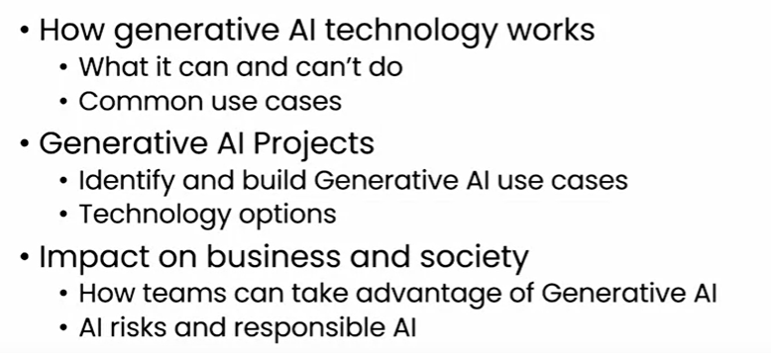

## How its works

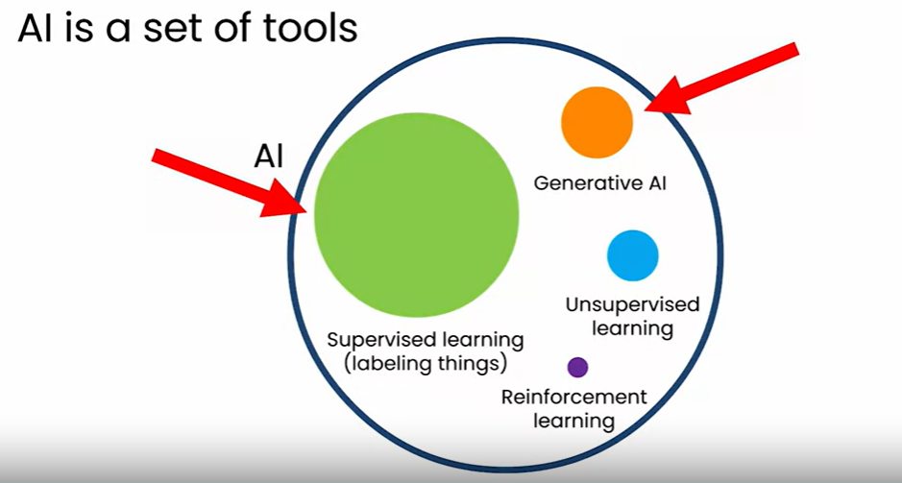

Supervised learning with LLM

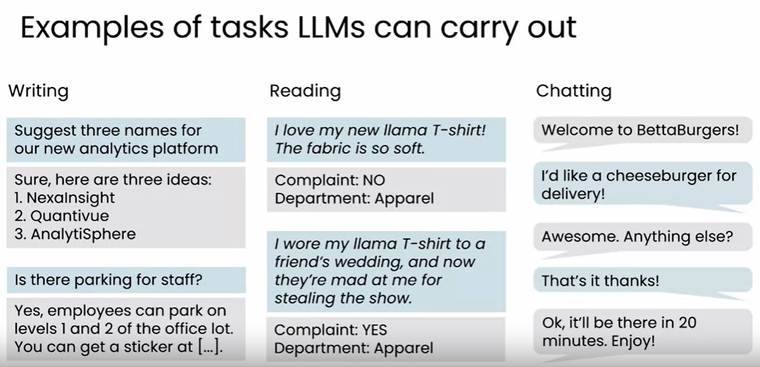

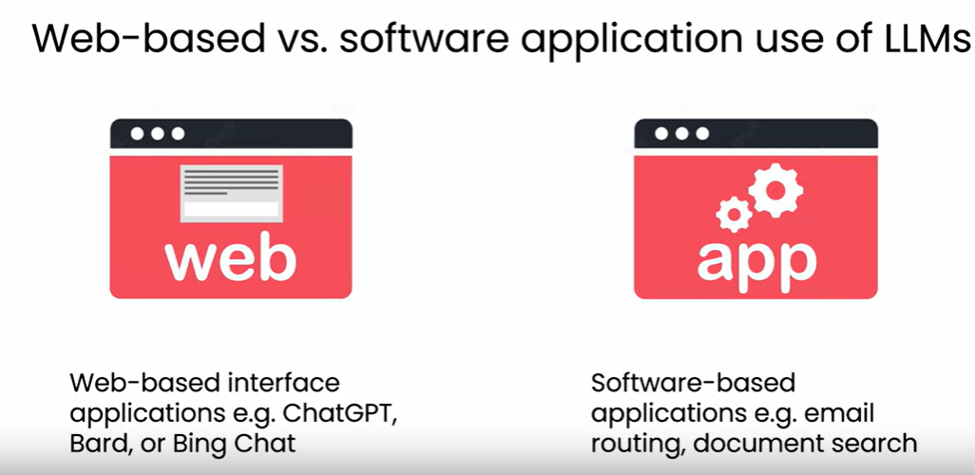

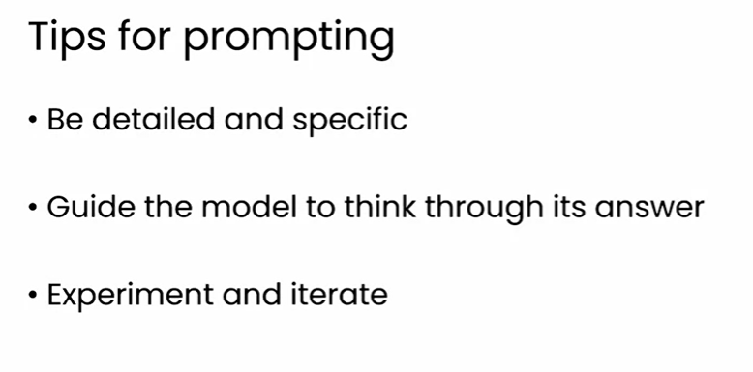

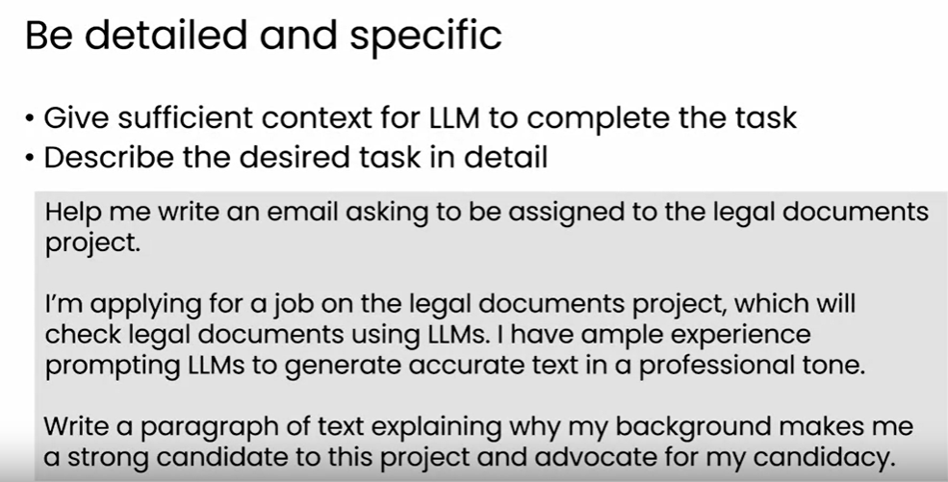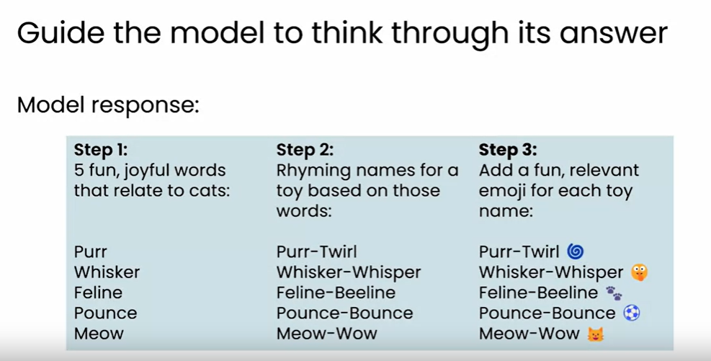

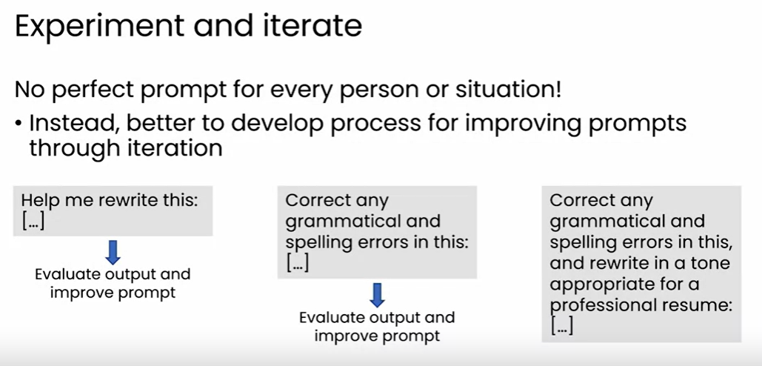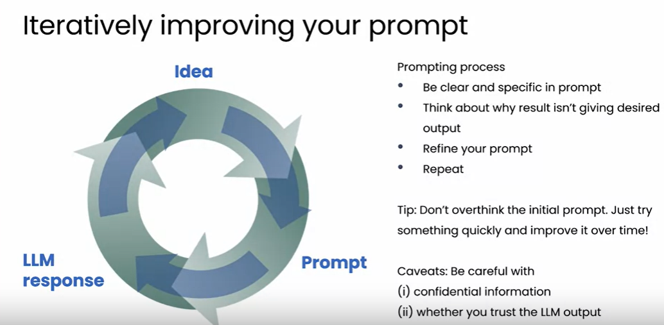

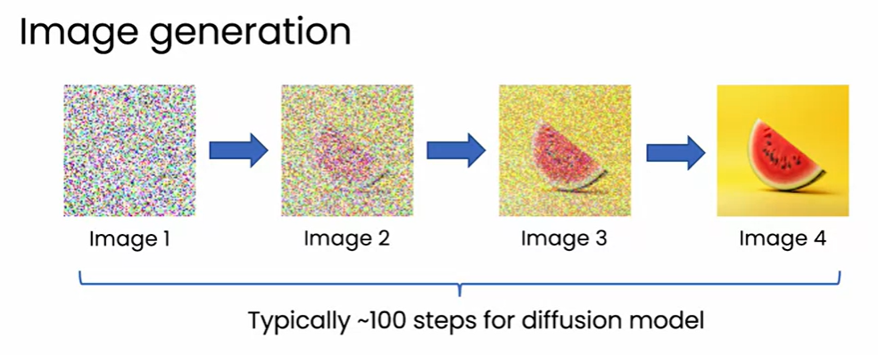

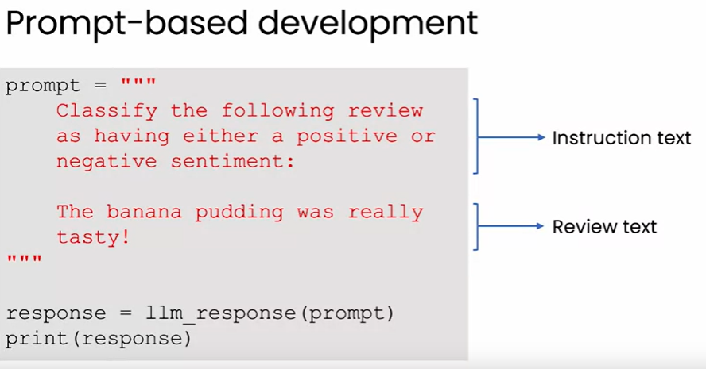

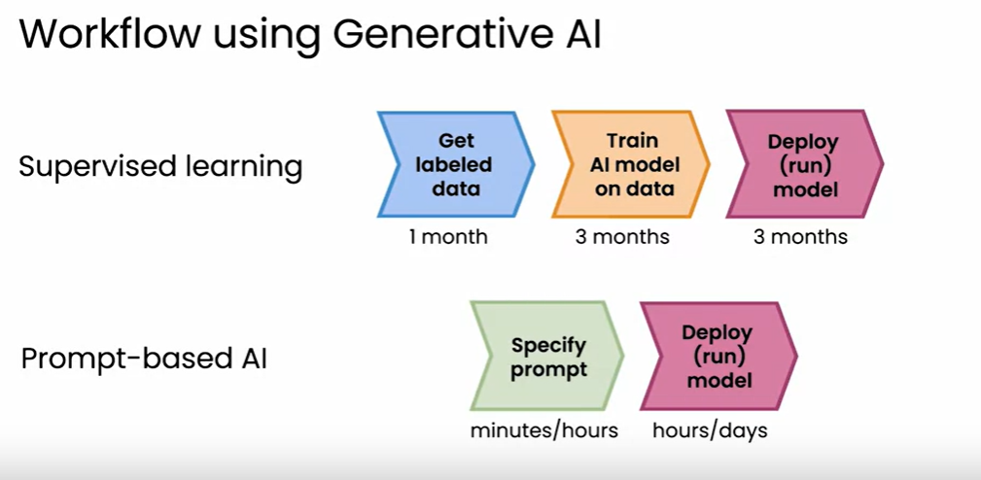

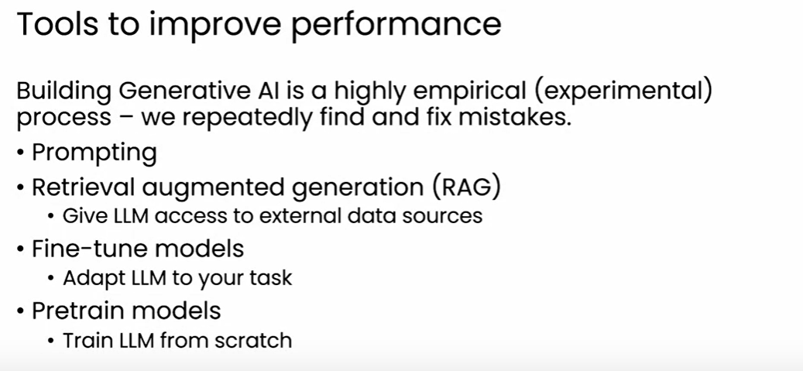

## **Life Cycle of Generative AI**

* 
* The ability of LLMs to process information is one of the features that makes them such powerful and useful tools.
* RAG can be used to give an LLM access to new, trusted sources of information that it can reason through to formulate an answer to your question. This helps prevent the model from hallucinating because it doesn’t know the answer.
* Fine-tuning an existing model is an effective way to get it to learn how to correctly route emails to the specific departments in the ecommerce company. Fine-tuning can be done well with 1000 to 10,000 examples.
* 

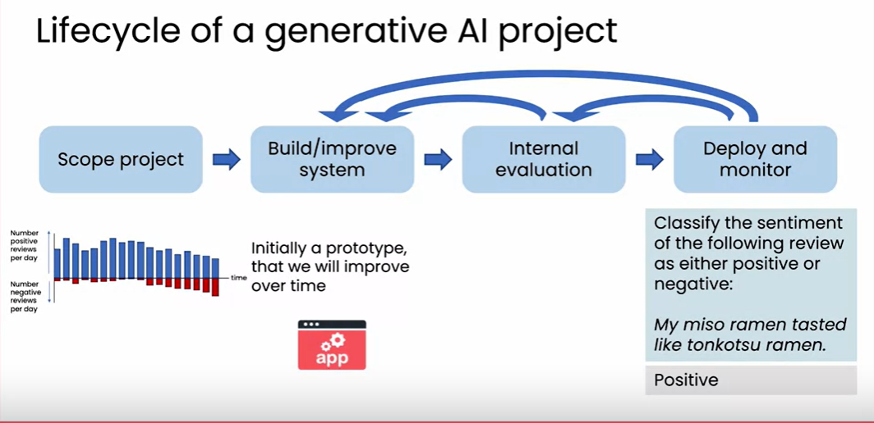

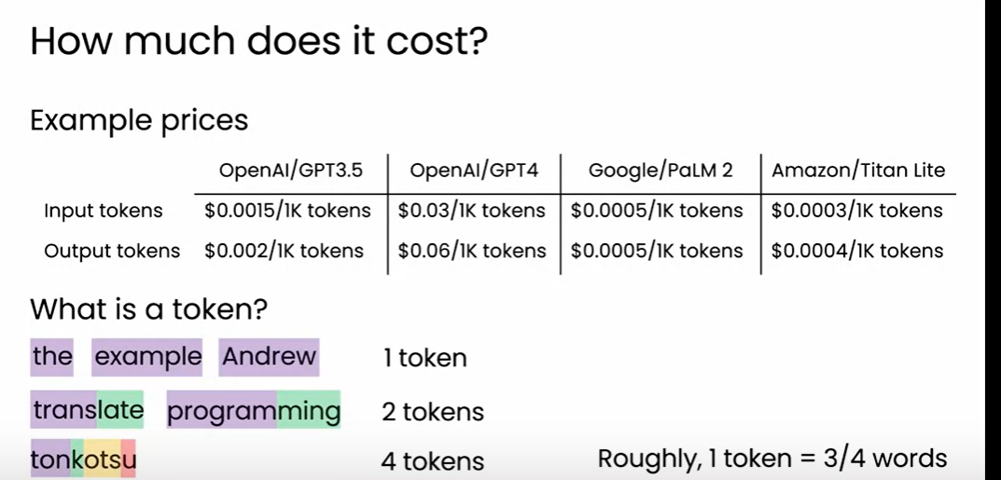

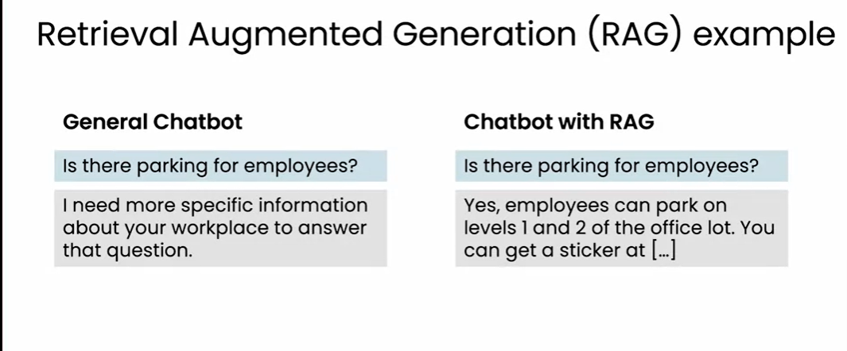  
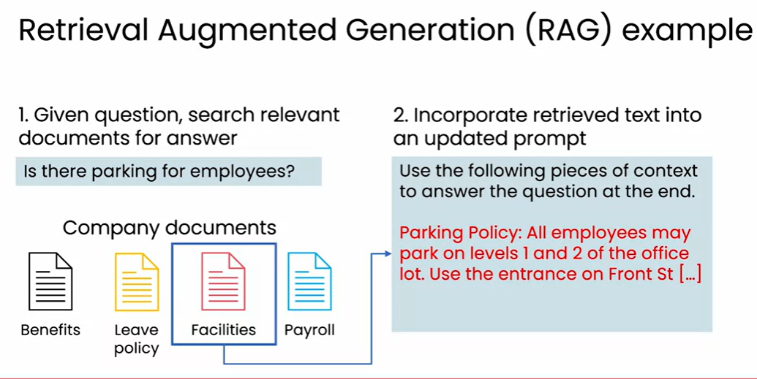

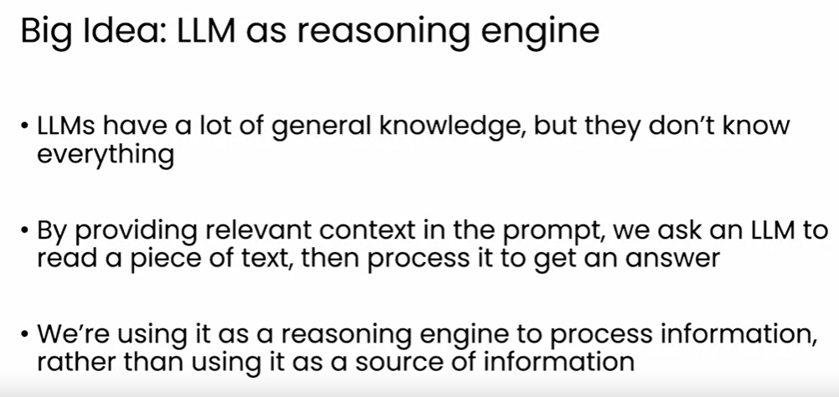

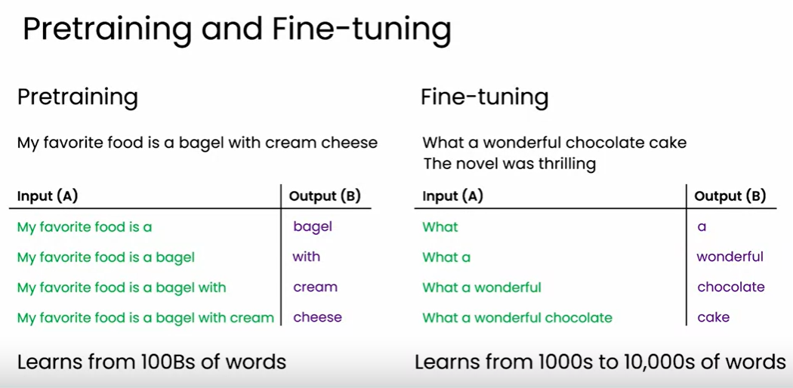

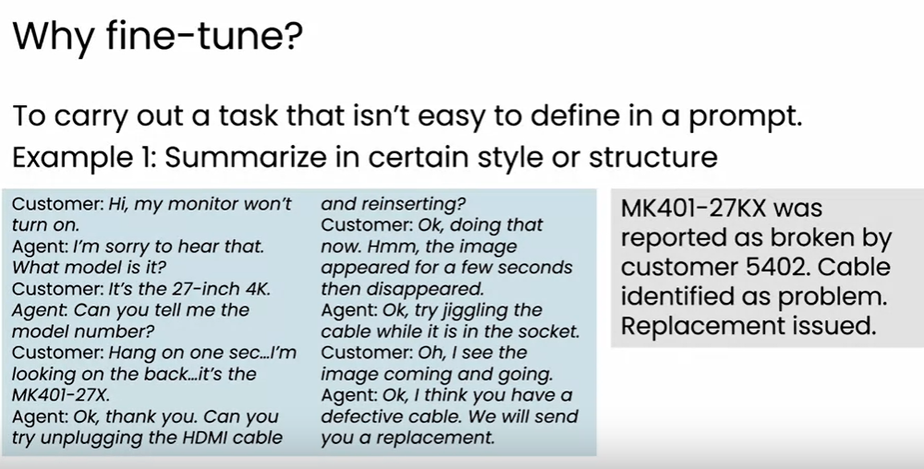

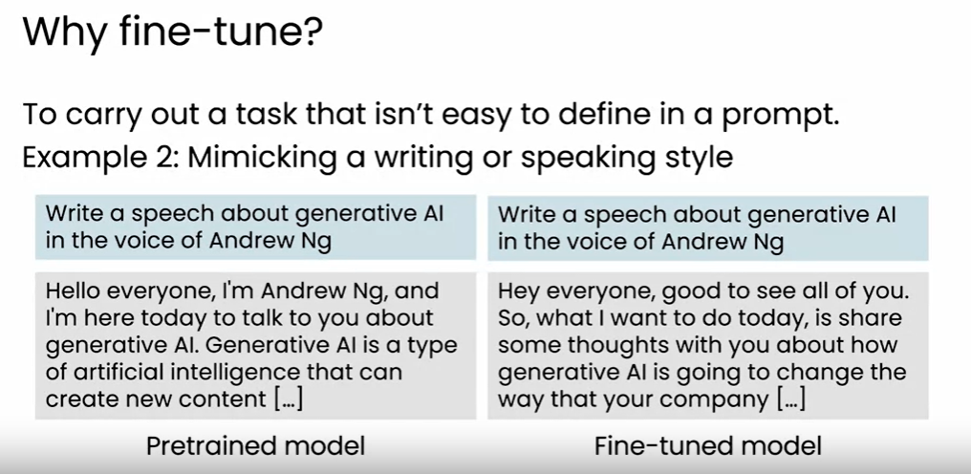

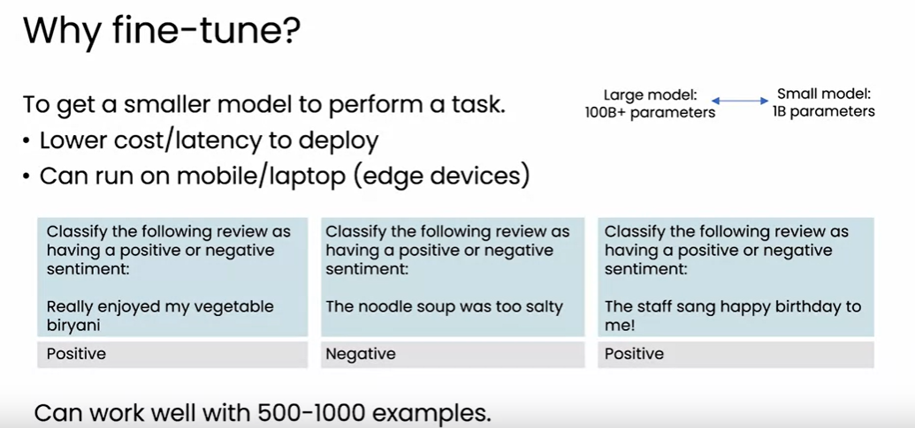

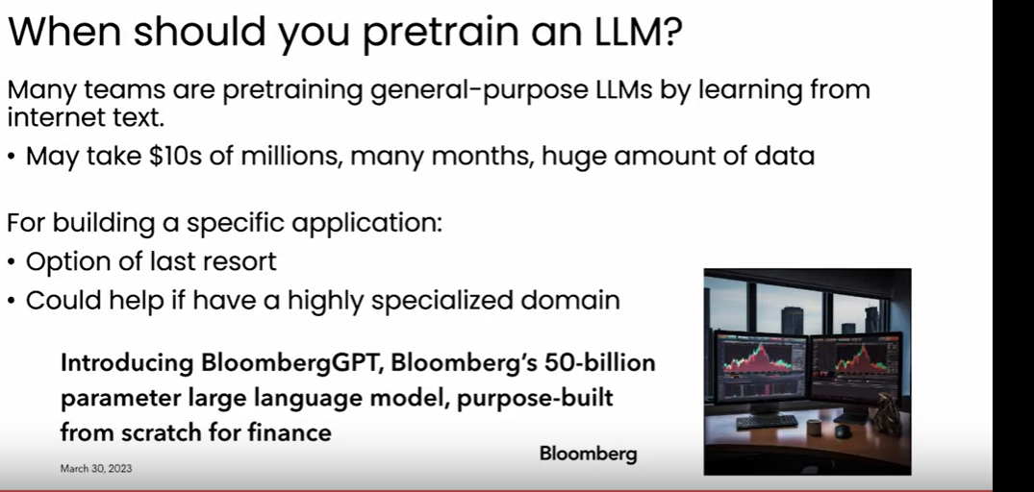

Choosing a Model:  
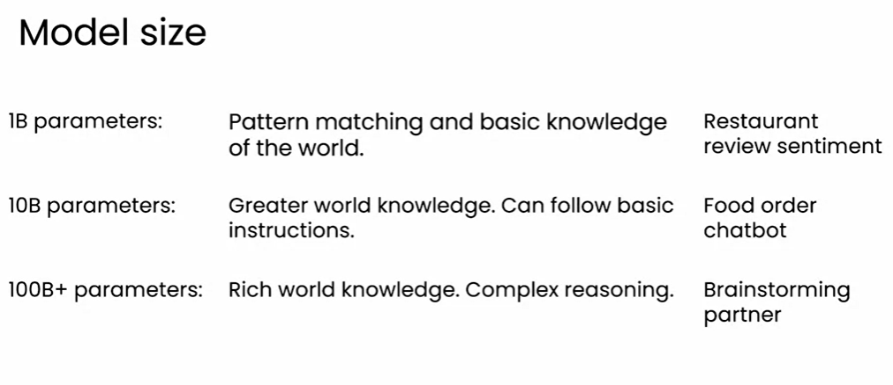

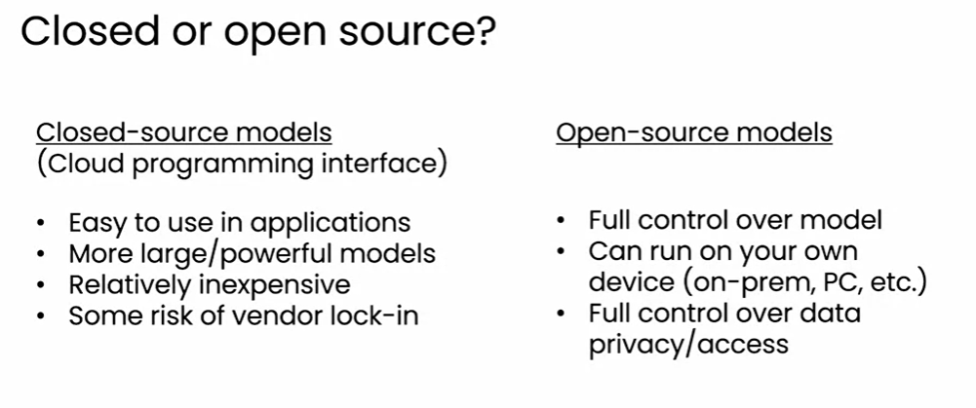

* LLM
* RAG
* Pretraining
* Fine-Tune

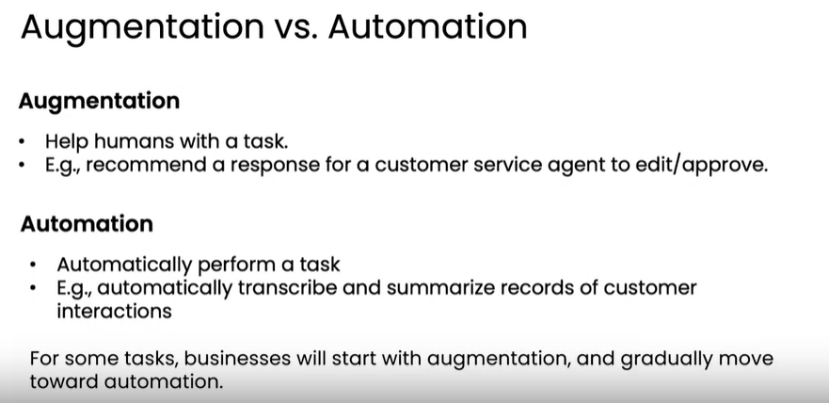

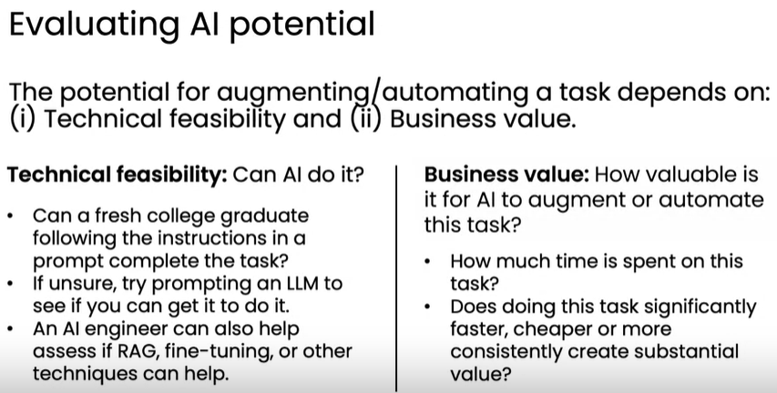

## Building team for Generative AI

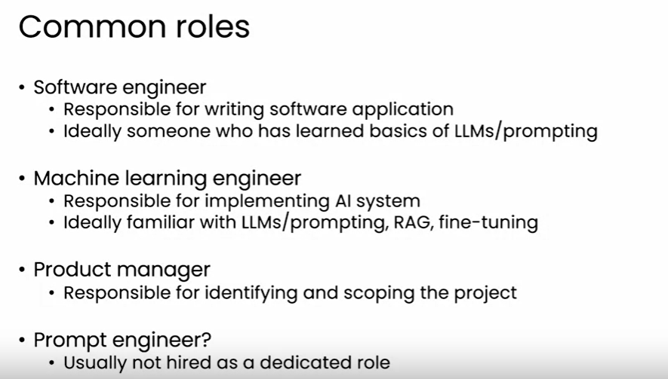

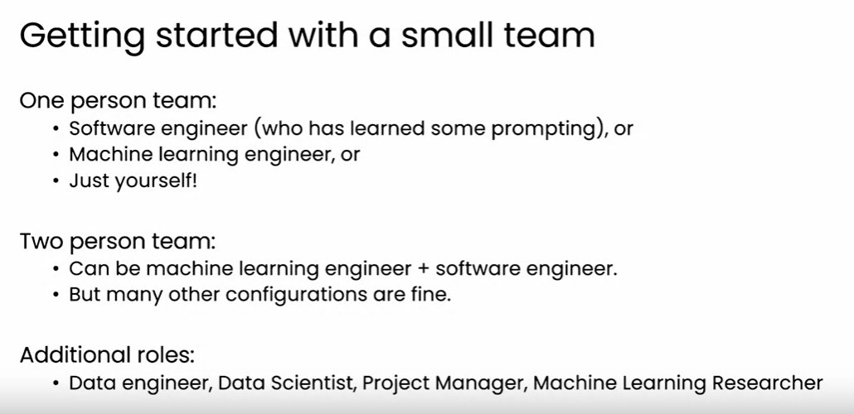

**Concerns About AI**

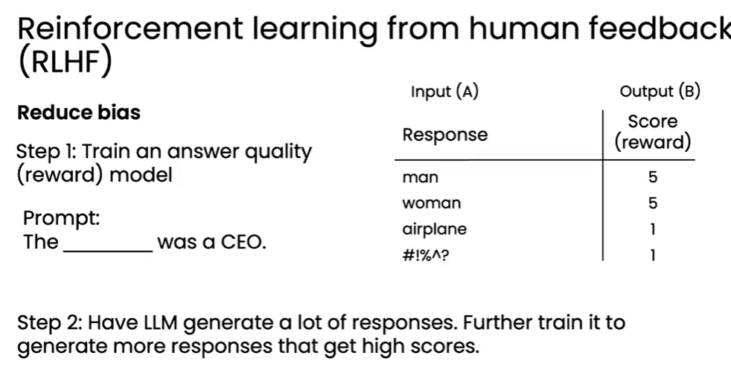

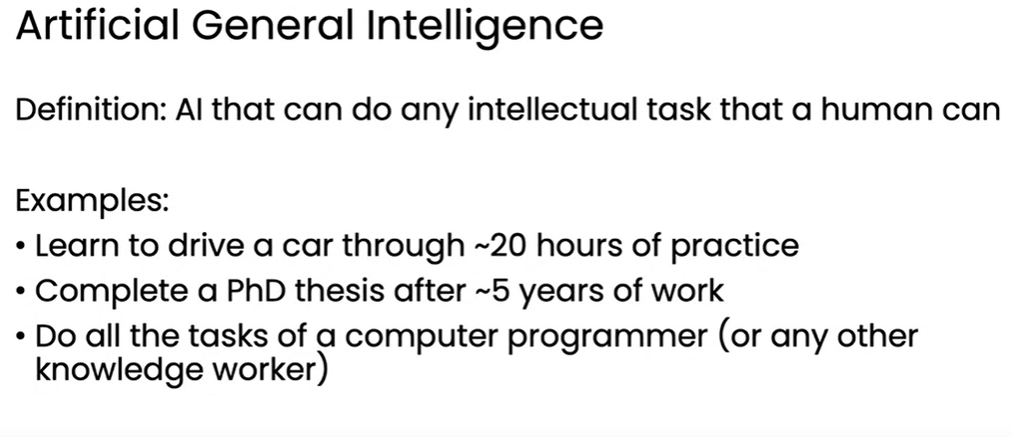

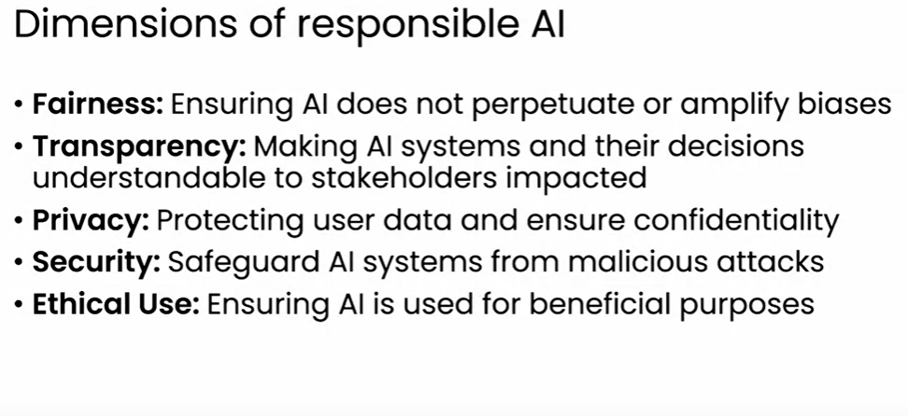

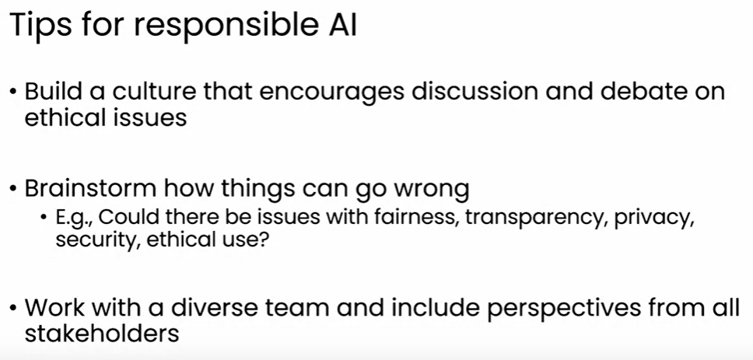

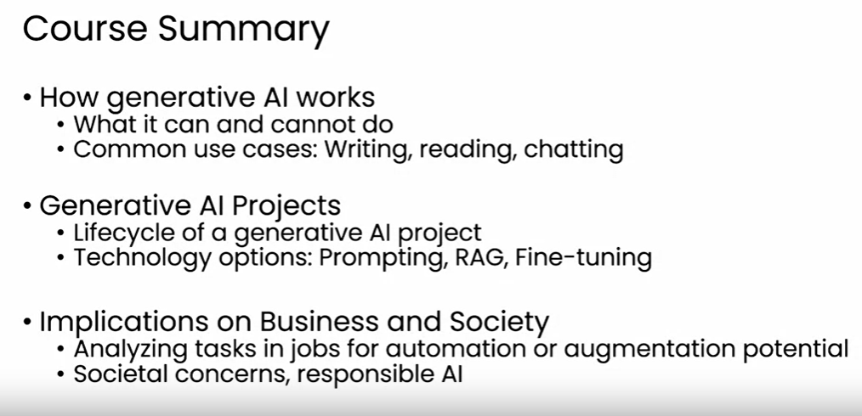

These instructions are called **prompts.** Prompts are the input to an LLM and their purpose is to tell the LLM what to do or how to think about a problem to get the best and most accurate output to a task possible. Adjusting a prompt to get more specific/usable responses from an LLM is called **prompt engineering** and is a key skill; it’s the biggest part of the effort of using LLMs.

# Prompt Engineering

Prompt engineering is the process to designing the effective prompts to unlock the full potential of Gen AI models.

best practices for creating prompts

1. Use clear, direct, and concise instructions
2. Try “complete this sentence” prompts for more natural responses
3. Use examples (few-shot learning) of the task
4. Align prompt instructions with a clear end goal
5. Use persona keywords to alter the style and voice of the response
6. Constrain the LLM’s responses by listing desired responses in the prompt
7. Experiment with variations of the prompt to see what works best for you!

Prompt is skill and technique to unlock the full potential of Generative AI. the techniques, approaches, and best practices for writing effective prompts**.**

Prompt engineering approaches like Interview Pattern, Chain-of-Thought, and Tree-of-Thought, which aim at generating precise and relevant responses.

Prompt engineering tools like IBM watsonx Prompt Lab, Spellbook, and Dust.

What is Prompt.

* A prompt is any input or series of instructions used to produce a desired output.
* These instructions help in directing the creativity of generative model.
* Building blocks of a well-structured prompt include instruction, context, input data, and output indicators.
* These elements help the model comprehend our necessities and generate relevant responses.

What is prompt Engineering

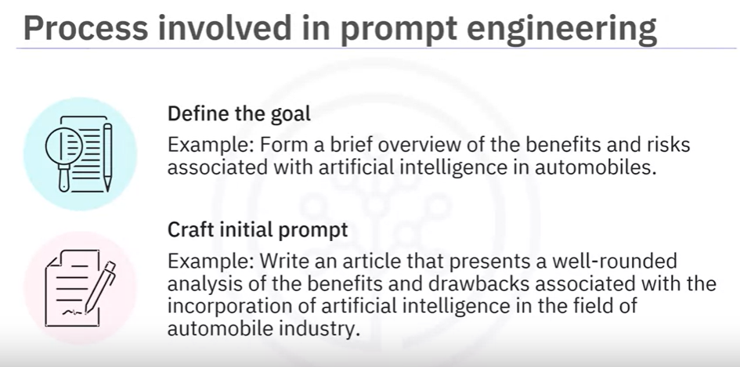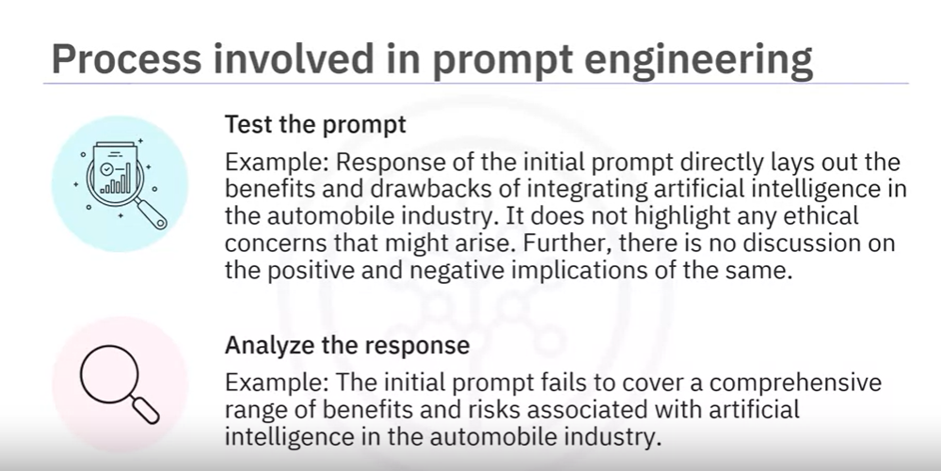

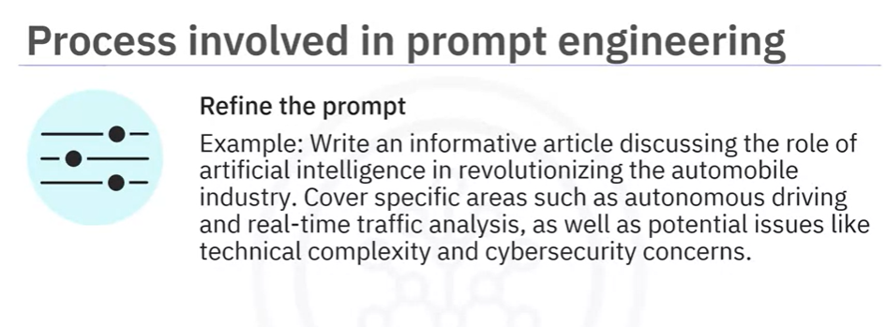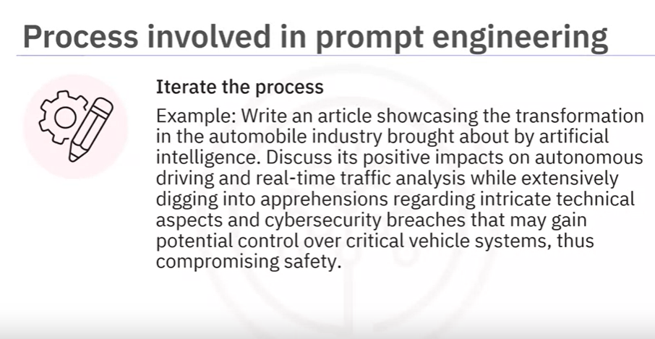

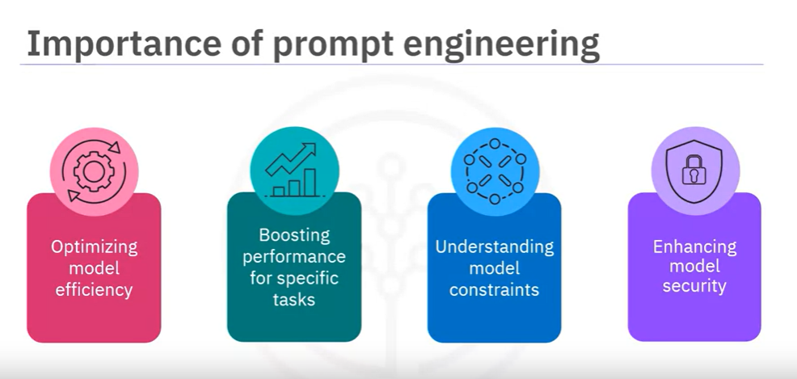

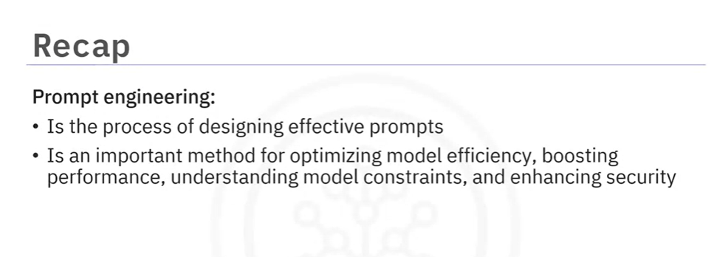

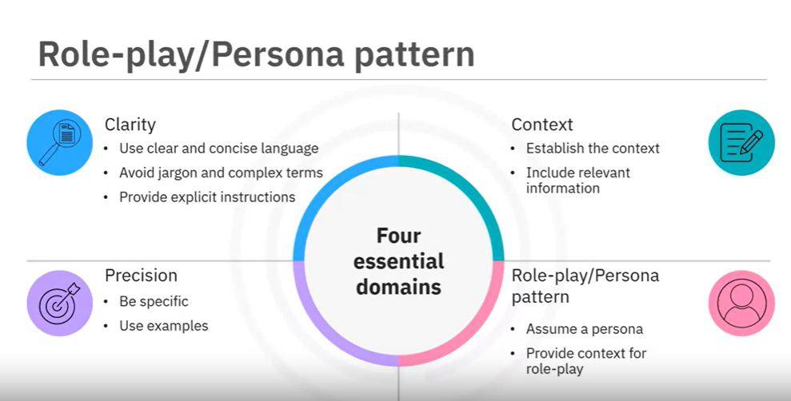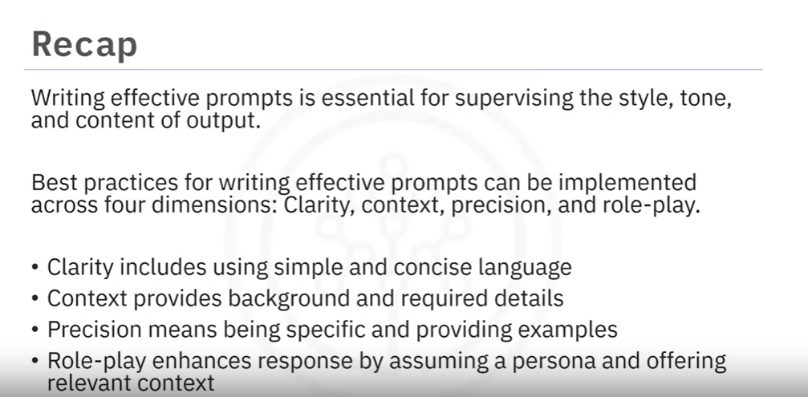

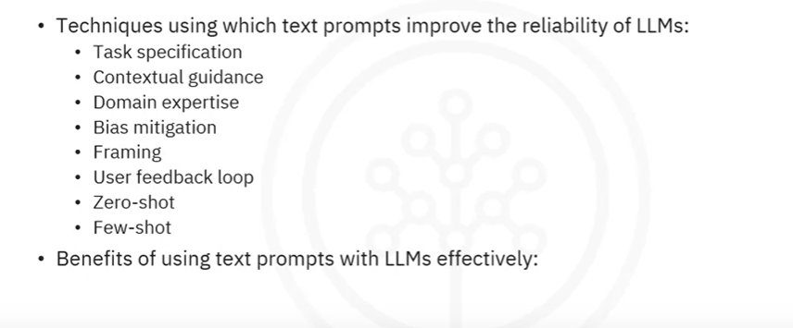

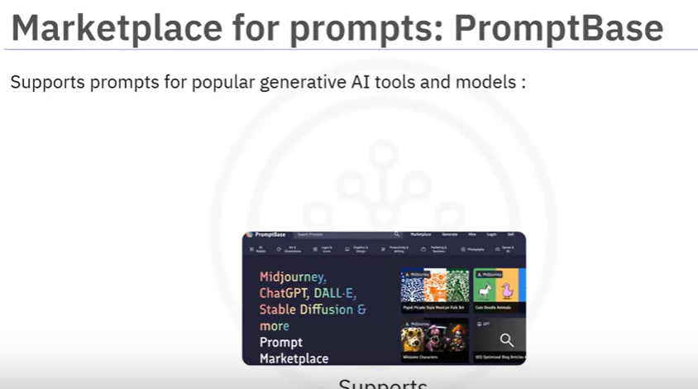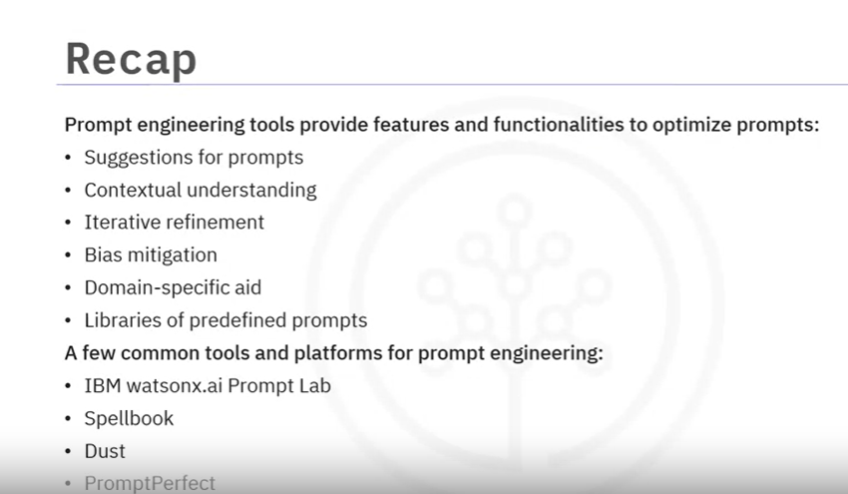

Specifically, you learned that:

naive prompting and persona patterns

* A prompt is any input or a series of instructions you provide to a generative model to produce a desired output.
* These instructions help in directing the creativity of the model and assist it in producing relevant and logical responses.
* The building blocks of a well-structured prompt include instruction, context, input data, and output indicators.
* These elements help the model comprehend our necessities and generate relevant responses.
* Prompt engineering is designing effective prompts to leverage the full capabilities of the generative AI models in producing optimal responses.
* Refining a prompt involves experimenting with various factors that could influence the output from the model.
* Prompt engineering helps optimize model efficiency, boost performance, understand model constraints, and enhance its security.
* Writing effective prompts is essential for supervising the style, tone, and content of output.
* Best practices for writing effective prompts can be implemented across four dimensions: clarity, context, precision, and role-play.
* Prompt engineering tools provide various features and functionalities to optimize prompts.
* Some of these functionalities include suggestions for prompts, contextual understanding, iterative refinement, bias mitigation, domain-specific aid, and libraries of predefined prompts.
* A few common tools and platforms for prompt engineering include IBM watsonx Prompt Lab, Spellbook, Dust, and PromptPerfect.

## Techniques and Approaches for writing Effective prompts:

### The Interview Pattern Approach in Prompt Engineering

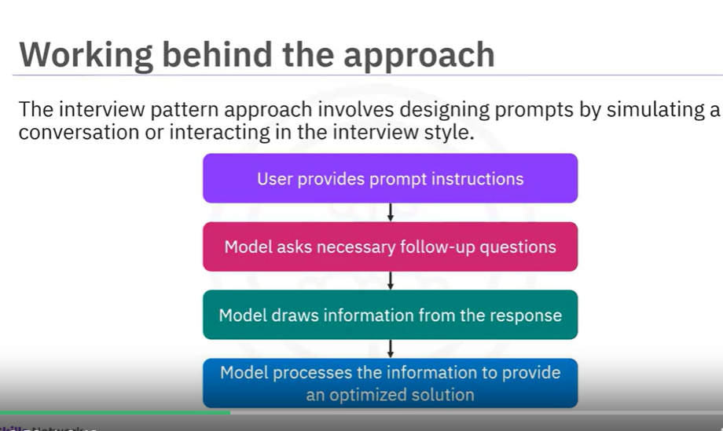

Follow up questions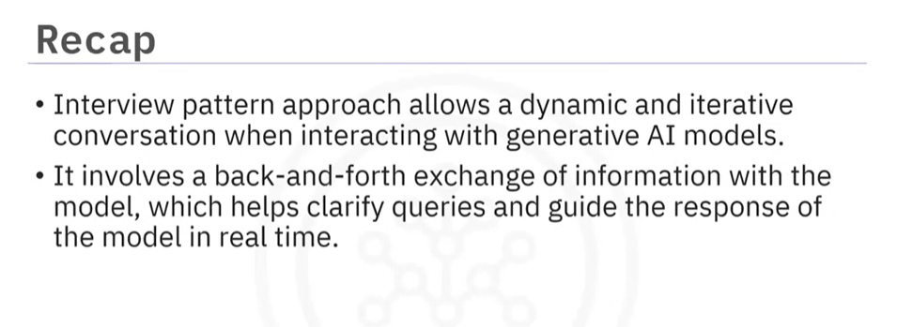

The Chain-of-Thought (CoT) methodology significantly bolsters the cognitive performance of AI models by segmenting complex tasks into more manageable steps. By adopting this prompting strategy, AI models can demonstrate heightened cognitive abilities and offer a deeper understanding of their reasoning processes.

 Chain-of-Thought prompting solicits a step-by-step thinking process from the LLM. Compared to the naive/standard/Input-Output prompting, we get far better results with it.

Tree-of-thought prompting uses a similar approach that not only invites the AI to consider a step-by-step process and to think logically but also makes it consider intermediate thoughts, building upon them and exploring branches that may or may not lead somewhere. This exploration maximizes the use of LLM and its capabilities, leading to drastically more useful results.

The various techniques using which text prompts can improve the reliability and quality of the output generated from LLMs are task specification, contextual guidance, domain expertise, bias mitigation, framing, and the user feedback loop.

* The zero-shot prompting technique refers to the capability of LLMs to generate meaningful responses to prompts without needing prior training.
* The few-shot prompting technique used with LLMs relies on in-context learning, wherein demonstrations are provided in the prompt to steer the model toward better performance.
* The several benefits of using text prompts with LLMs effectively are increasing the explain ability of LLMs, addressing ethical considerations, and building user trust.
* The interview pattern approach is superior to the conventional prompting approach as it allows a more dynamic and iterative conversation when interacting with generative AI models.
* The Chain-of-Thought approach strengthens the cognitive abilities of generative AI models and solicits a step-by-step thinking process.
* The Tree-of-Thought approach is an innovative technique that builds upon the Chain-of-Thought approach and involves structuring prompts hierarchically, akin to a tree, to guide the model's reasoning and output generation.

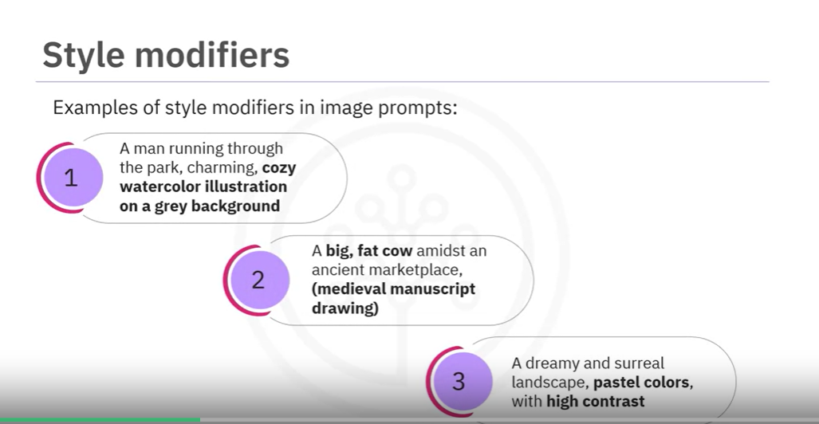;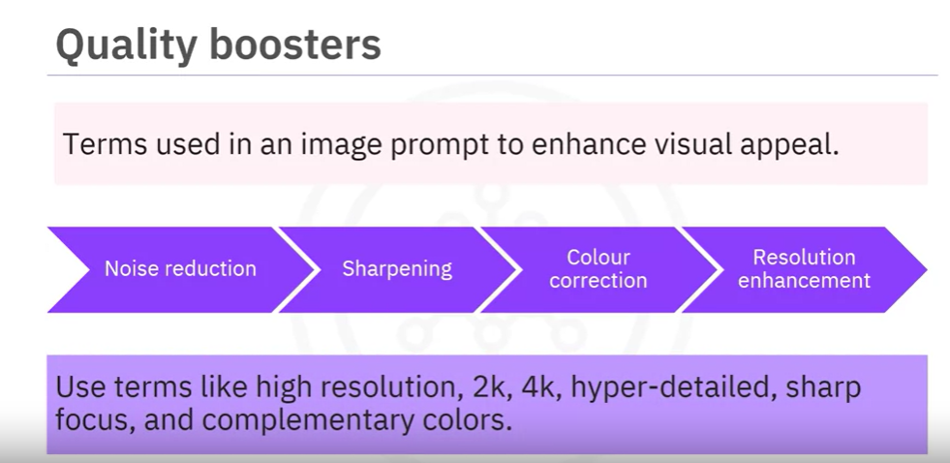

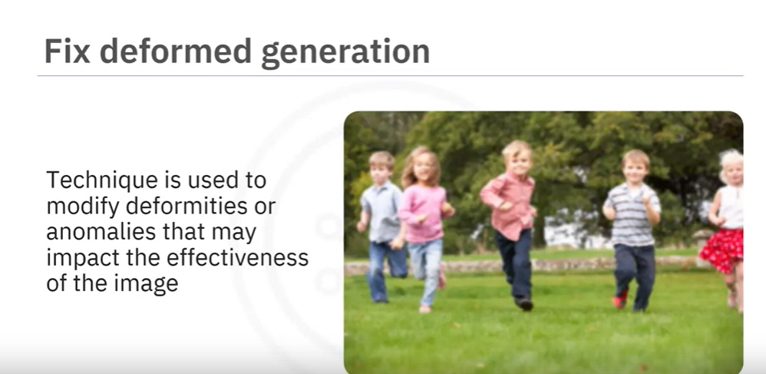

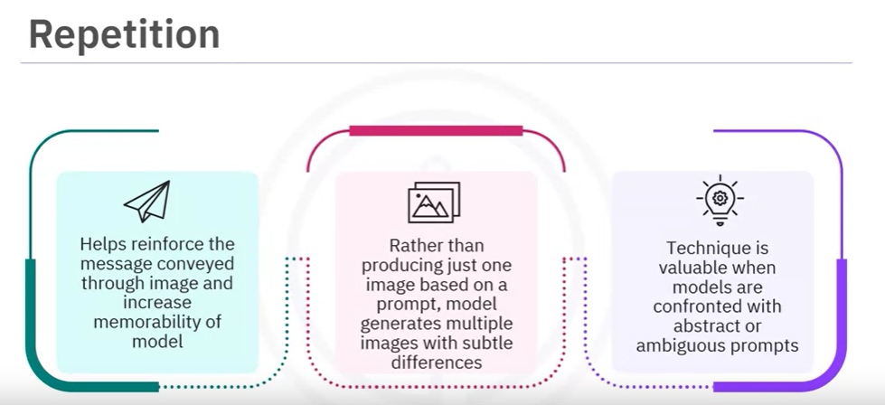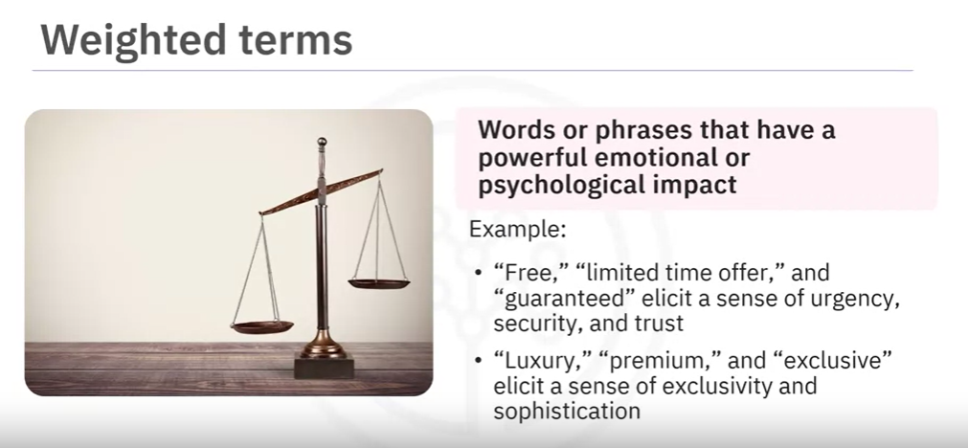

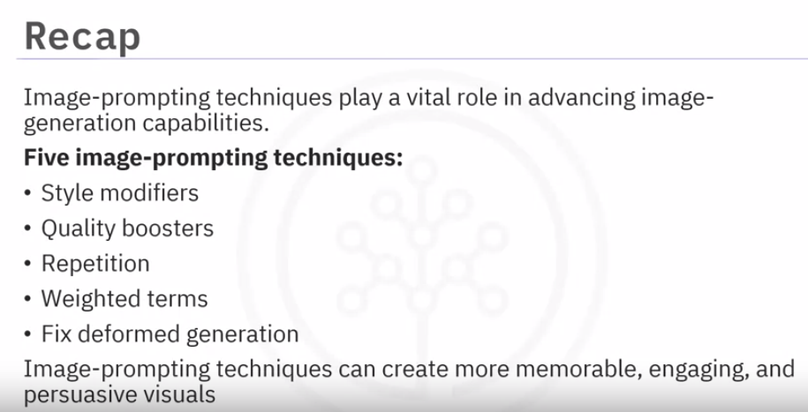

# **NLP- Natural Language Processing**

Is process of modelling a computer system for better understanding, analysing, interpretation and responding to the human language like the way how the humans would it. NLP algorithms and models improves the accuracy and efficiency of communication between the humans and computers.

Natural Language Processing (NLP) is a subfield of Artificial Intelligence (AI) that focuses on the interaction between computers and humans using natural language. One of the key benefits of NLP is its ability to improve the accuracy and efficiency of communication between humans and computers.

The goal of NLP is to enable computers to understand, interpret, and respond to human language in a way that is similar to how a human would.t

<https://www.nomidl.com/natural-language-processing/30-days-of-natural-language-processing-nlp/>

## Pre-processing:

 pre-processing text data is an important step in any NLP project. Text cleaning and normalization help to improve the quality of the data and make it easier for NLP algorithms and models to process.

The aim of pre-processing is to improve the quality of the data and make it easier for NLP algorithms to process

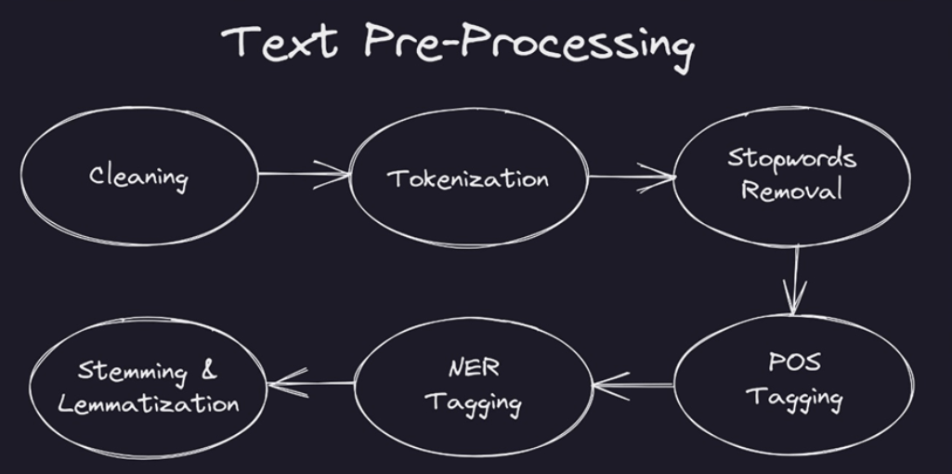

### **Clean Text for NLP : Text Cleaning**

<https://www.nomidl.com/natural-language-processing/pre-processing-text-data-cleaning-and-normalization/>.

Text cleaning is the process of removing any unwanted or irrelevant information from the text data. This includes removing special characters, numbers, punctuation, and stop words.

#### Tokenization and stopword removal

Tokenization is the process of breaking down a larger piece of text into smaller units, called tokens, which can then be used for further analysis. Tokens can be words, phrases, sentences, or even stop words, depending on the NLP task.

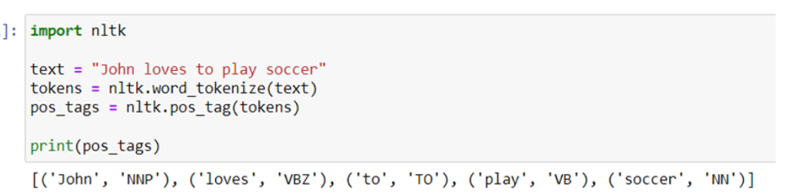

**1 – Part-of-Speech (POS) tagging** is the process of labelling each word in a text corpus with its corresponding part of speech, such as noun, verb, adjective, adverb, etc. This can be useful for identifying the structure and meaning of a sentence, as well as for tasks like sentiment analysis and text classification.

**2 – Named Entity Recognition (NER)**is the process of identifying and classifying the entities in text, such as people, organization, locations, and dates. This can be useful for tasks like information extraction and question answering.

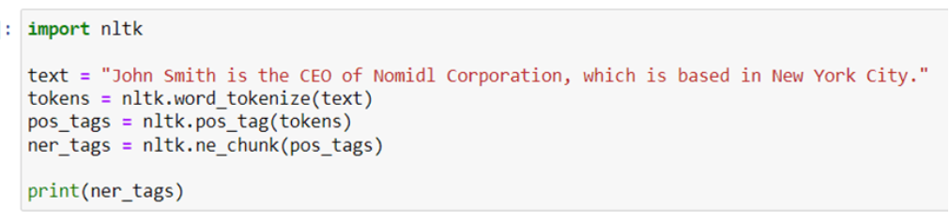

Stop word removal is the process of removing common words, such as “the”, “and”, “a”, etc., from the text data.

### **Text Normalization:**

Text normalization is the process of converting the text data into a standard format so that it can be processed effectively by NLP algorithms and models. This includes techniques such as stemming, lemmatization, and case normalization.

Stemming is the process of reducing words to their root form, which is called the stem. For example, the stem of the word “running” is “run”. Stemming algorithms are based on rules and heuristics that remove affixes and suffixes t o generate the stem of the word.

Lemmatization is the process of reducing words to their base form or dictionary form, which is called the lemma. Unlike stemming, lemmatization takes into consideration the context of the word and its grammar, which makes it more accurate.

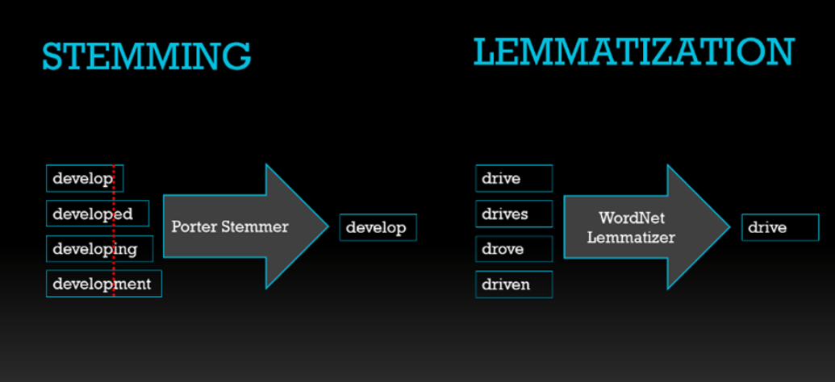

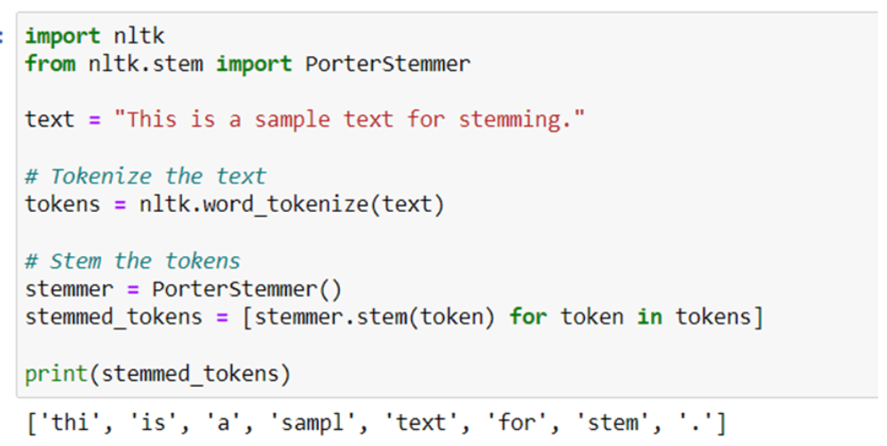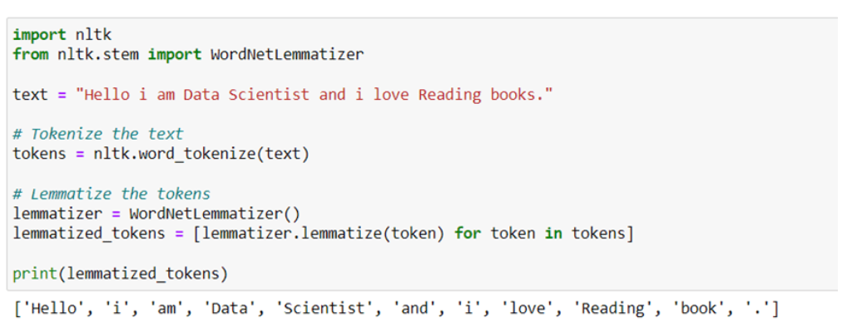

Case normalization is the process of converting the text data into a standard case, such as lowercase or uppercase.

### **Word Embeddings**

Word embeddings are a way to represent words as numerical vectors that capture their semantic meaning based on the contexts in which they occur.

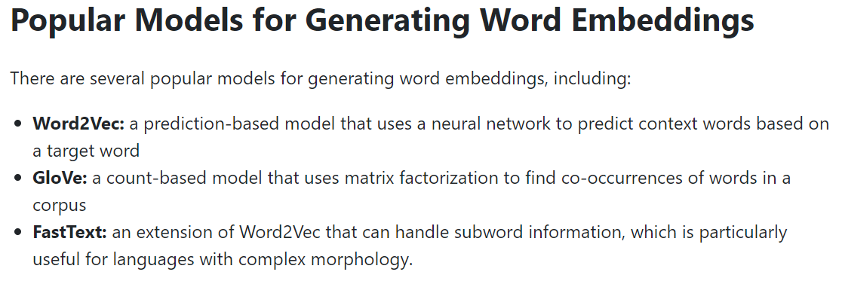

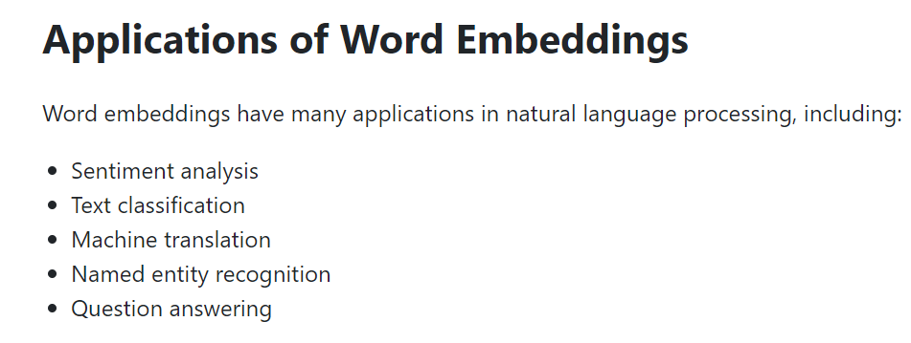

### **Sentiment Analysis Model**

Sentiment analysis refers to the process of determining the emotional tone behind a piece of text, whether it is positive, negative, or neutral.

**Steps for Building a Sentiment Analysis Model:**

**1 – Data Collection:** The first step in building a sentiment analysis model is to collect data. You can collect data from various sources such as social media platforms, product reviews, or customer feedback forms.

**2 – Data Pre-processing:** Once you have collected the data, the next step is to pre-process it. This includes removing stop words, stemming, or lemmatizing the words, and converting the text into a numerical representation.

**3 – Feature Extraction:** The next step is to extract features from the pre-processed data. One of the most popular feature extraction techniques used in sentiment analysis is Bag-of-Words (Bow). It involves creating a vocabulary of unique words and representing each document as a vector of word frequencies.

**4 – Training the Model:** After feature extraction, the next step is to train the model. There are various algorithms that can be used to train a sentiment analysis model such as Naive Bayes, Logistic Regression, or Support Vector Machines (SVM).

**5 – Model Evaluation:** Once the model is trained, the next step is to evaluate its performance. You can use various evaluation metrics such as accuracy, precision, recall, and F1-score to evaluate the performance of the model.

**6 – Prediction:** After evaluating the model’s performance, you can use it to predict the sentiment of new text data.

### **Text Classification with Naïve Bayes**

Text Classification is a popular technique used in Natural Language Processing to categorize text documents into predefined categories. Naïve Bayes is a commonly used algorithm for text classification, as it is simple and efficient.

# Generative AI – INEURON

Step 1: setup the virtual environment from conda

Step2: create the client(client = OpenAI(api_key=OPENAI_KEY)) from LLM by importing OpenAI from openai module.

client = OpenAI(openai_api_key=OPENAI_KEY)

Step3: start the prompting -

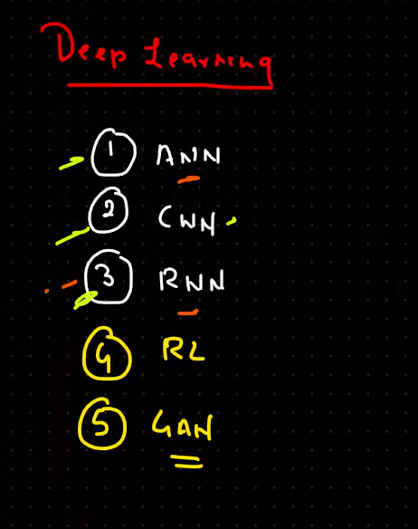

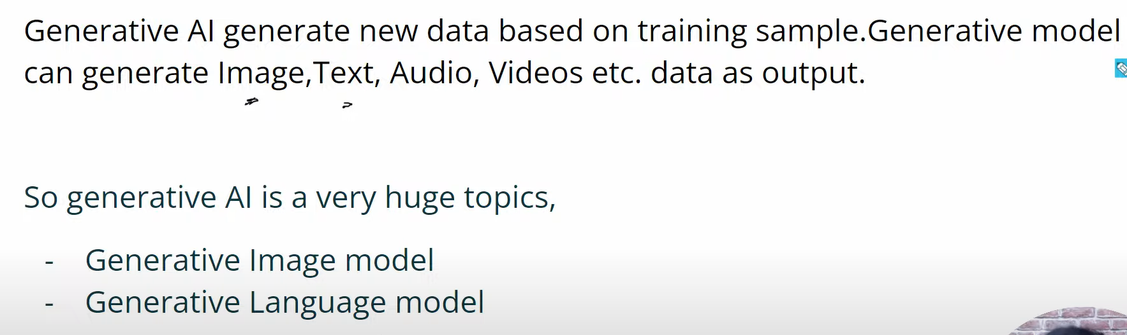

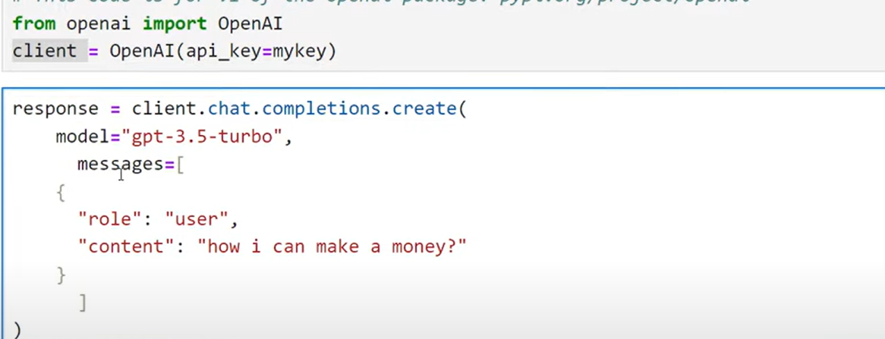

Chat Completion API:

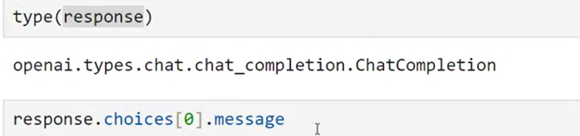

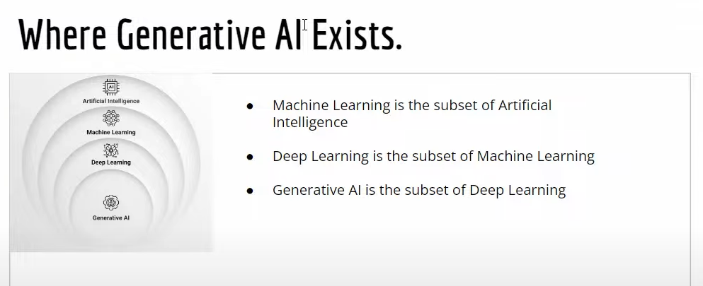

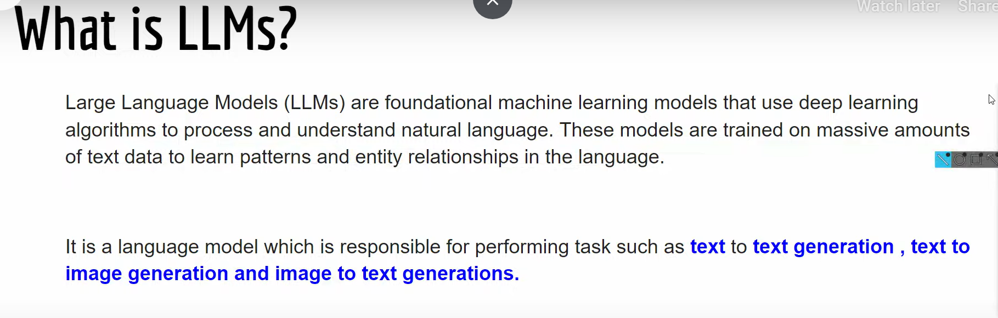Few shot prompting is technique to clearly specifying the goal what to do with the prompt. For this type of prompt LLM needs to be pre-trained with how to achieve the specified task. That is implemented by function calling or for the real time data getting form external sources

Function Calling:

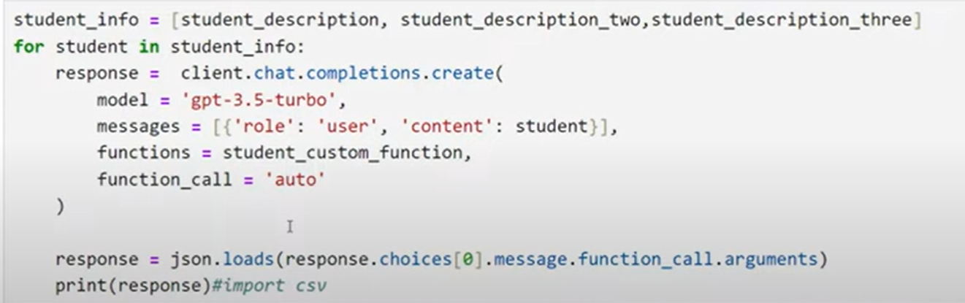

## Langchain >

using the Langchain API can access different LLM model by using diff API

can access private data sources and can access any third party LLM

Langchain parts:

### LLM

import langchain

from langchain.llms import OpenAI

client= OpenAI(openai_api_key=OPENAI_KEY)

print(client.predict(prompt).strip())

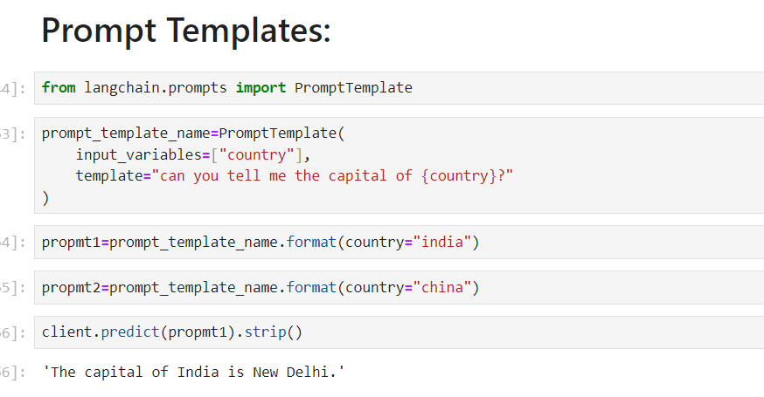

### Agents

* For getting real time info use the serp api

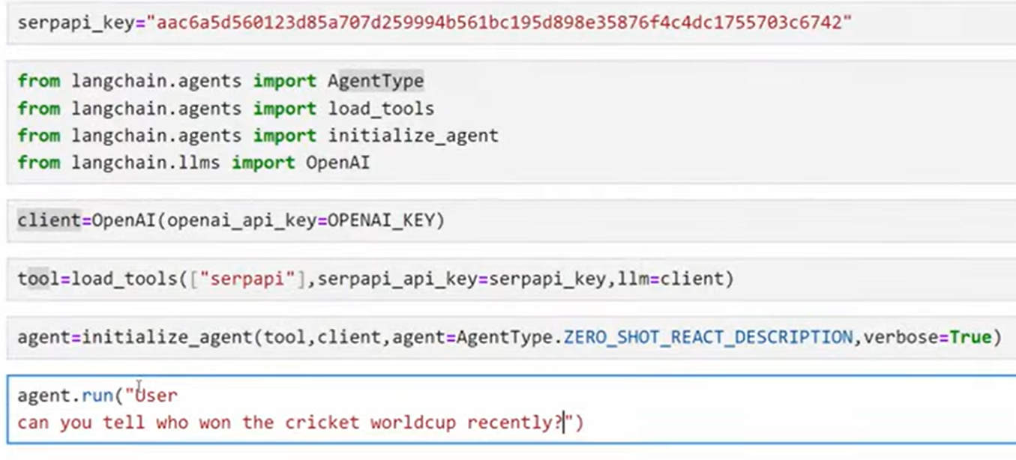

### Chain

Central to LangChain is a vital component known as LangChain Chains, forming the core connection among one or several large language models (LLMs). In certain sophisticated applications, it becomes necessary to chain LLMs together, either with each other or with other elements.

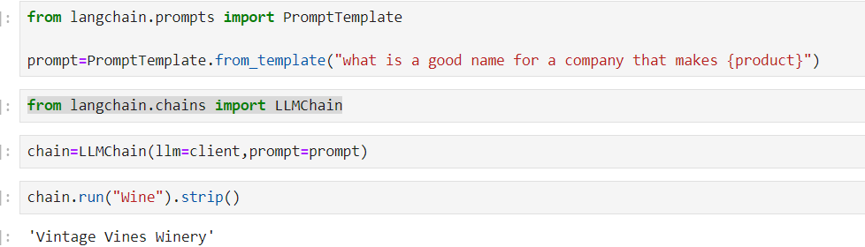

### Document Loader

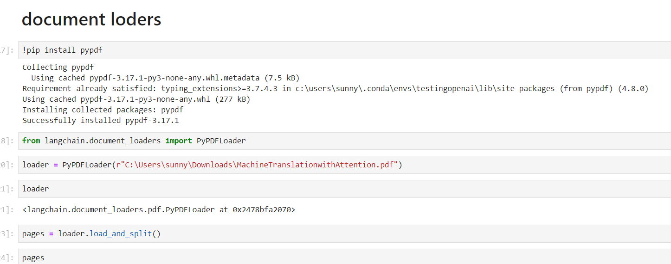

### Memory in Langchain

**Prompt Template:** a predefined prompts for better results